3XPHY

Unit 4

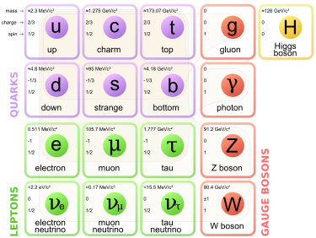

Standard Model

REMOVE ANSWERS

The Big Bang theory describes the early development of the universe, including the formation of subatomic particles from energy and the subsequent formation of atomic nuclei. There is a variety of evidence that supports the Big Bang theory, including Cosmic Background Radiation, the abundance of light elements and the red shift of light from galaxies that obey Hubble’s Law. Alternative theories exist, including the Steady State theory, but the Big Bang theory is the most widely accepted theory today.
The Standard Model is used to describe the evolution of forces and the creation of matter in the Big Bang theory

The Big Bang

- There is good evidence that the Universe had a beginning – the Big Bang
- ~13.7 billion years ago, the Universe was compressed into a singularity – zero volume, infinity density

- The Big Bang created time and space.

- The Universe is expanding, cooling, becoming less dense.

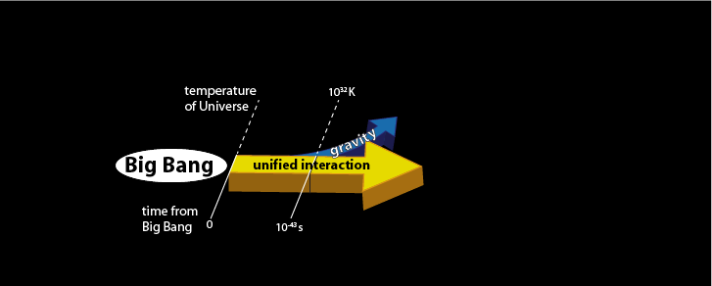
- The four forces in the Universe – gravity, strong force, weak force and electromagnetism were initially unified.

- 10⁻⁴³ seconds after the Big Bang, gravity gets separated. Expansion rapidly increases.

- 10⁻³⁵ seconds after the Big Bang, the strong force gets separated.

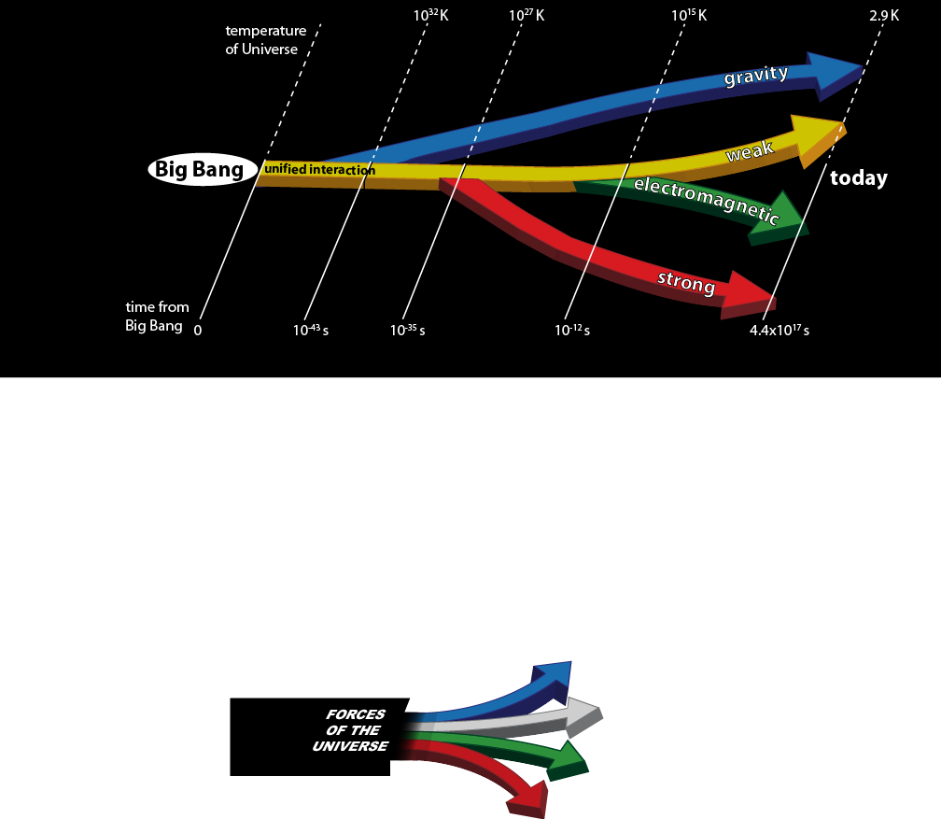
- Matter separates into quarks and leptons. It is too hot for quarks to combine.

- 10⁻¹² seconds after the Big Bang, the weak force and electromagnetism get separated.

- As temperature falls, quarks combine to form hadrons.
  - Matter is roughly equal amounts of matter and antimatter.
  - As temperature falls, matter and antimatter annihilate each other.
  - A small excess of particles were left – all the hadrons in the Universe today.

- As the hadrons are removed, leptons become the dominant form of matter.

- As temperature falls, leptons and antileptons annihilate each other.
  - A small excess of leptons were left – all the leptons in the Universe today.

- Protons and neutrons combine to form H nuclei.
  - H nuclei capture electrons to form stable atoms.

- Density of Universe decreases as it expands.

- Gravity clumps matter together.
  - This matter becomes hotter and denser and forms stars.
  - Fusion in stars creates heavier elements.
  - Stars form galaxies
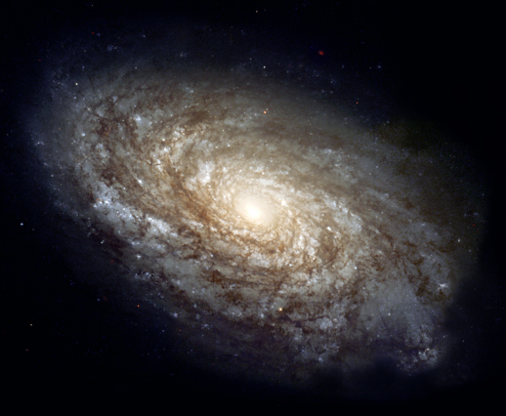

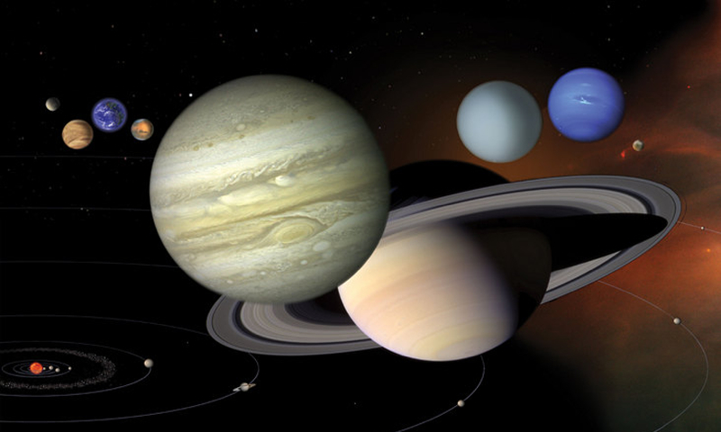

PP 9.4 p 378-81

The expansion of the universe can be explained by Hubble’s law and cosmological concepts, such as red shift and the Big Bang theory.

Scale of solar system, interstellar scales (stellar parallax), Universe
- The distance to other planets in our solar system, to other stars and beyond our galaxy is almost unimaginable.
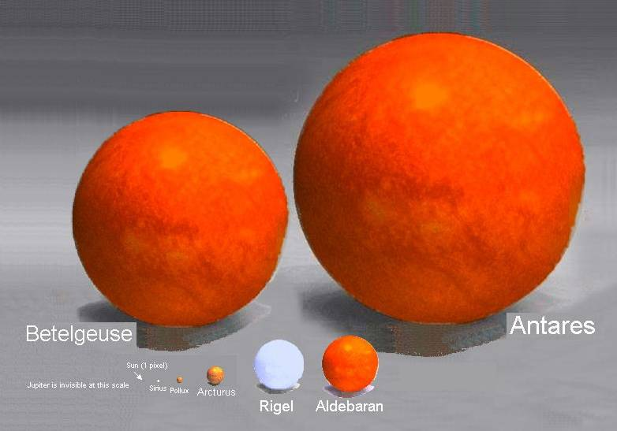
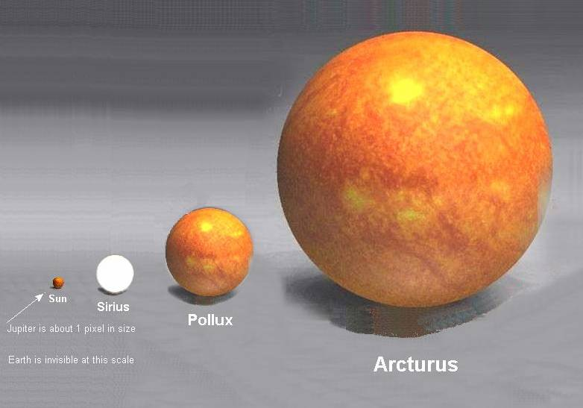
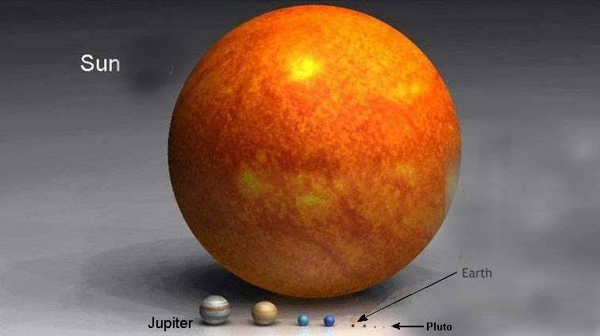
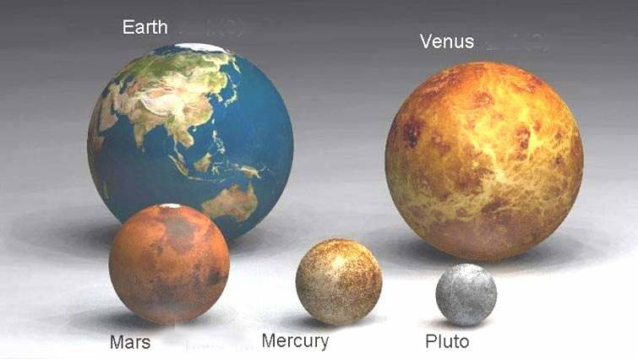
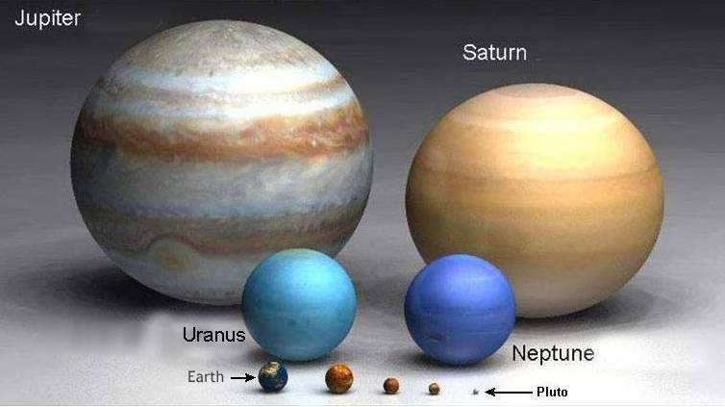
- Antares is the 15th brightest star in the sky. It is more than 1000 light years away.
As you can see, beyond our sun it's a big universe.
http://htwins.net/scale2/
Units of Astronomical Distance

- Light year:
  - A light year is the distance travelled by light in one year.
  - It is exactly 9,460,730,472,580.8 km.
  - It is based on exactly 365.25 days each with exactly 86,400 seconds (31,557,600 seconds in total) and defined as the speed of light of exactly 299,792,458 m s⁻¹.
    - Calculate the distance of 1 ly in km.

- A Light minute is the time light will travel in one minutes while a light hour is the time light travels in one hour.

- Parsec:
  - A parsec (pc) is a unit of length used in astronomy equal to 3.086 x 10¹³ km or about 3.26 light years.
  - A megaparsec is 3.086 x 10¹⁹ km which is the common unit for measuring distances between galaxies.
  - A Mpc = 3.26 x 10⁶ light years.
  - For example, the Andromeda Galaxy is 0.77 Mpc from the Earth.
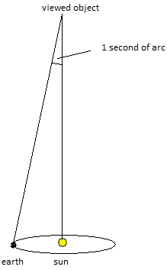

$$\frac{1}{3600}°$$

1 parsec (3.26 light years or 3.086 x 10¹³ km)

1 AU = average Earth – Sun distance
= 1.50 x 10¹¹ m

- Saturn is 1,427,000,000 km from the Sun. What is this distance in AU?

Calculations using the speed of light

- The distance to our closest neighbour, Alpha Centauri A & B is roughly 4.35 light years. Calculate this in kilometres and parsecs.

Kilometres: parsecs:

Determining stellar distances

- Parallax
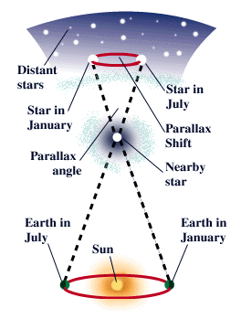
  - As the Earth revolves around the Sun, near stars seem to
shift their position against the farther stars.

  - This is called parallax shift.

  - By observing the distance of the shift and knowing the
diameter of the Earth's orbit, astronomers are able to
calculate the parallax angle across the sky.

  - The smaller the parallax shift, the farther away from earth
the star is.

  - This method is only accurate for stars within a few hundred
light-years of Earth.

  - When the stars are very far away, the parallax shift is too
small to measure.

- Cepheid Variables
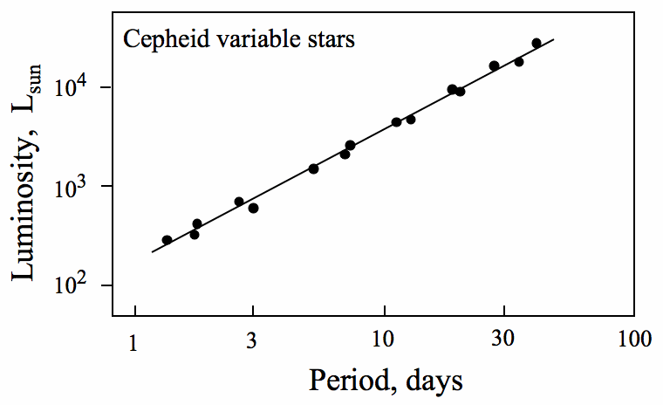
- Cepheid variable stars are very luminous
yellow supergiants that pulsate with
periods ranging from 1 to 50 days.
- The luminosity variations of these stars
are continuous and extremely regular,
allowing the periods of the stars to be
accurately measured.
- There is a relation between the period of
pulsation in a Cepheid star and its
brightness.
- Brighter stars were shown to have longer
periods.
- There is a relationship between
brightness and distance.

- Luminosity and distance

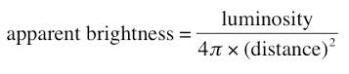
- By looking at luminosity and brightness of stars,
Astronomers can calculate approximate
distances.

- Redshift
  - This will explained in detail later

Observing the past

- Light may seem to travel fast at 3 x 10⁸ m s⁻¹ but when looking at objects in the sky, say the Andromeda Galaxy, which is about 2 x 10¹⁸ km away, that is a long distance for light to travel to our eyes.

- In fact, light takes about a second to get to the moon and back.

- That slow crawl of light across the universe means that what you're seeing when you look at stars is light that left them many years ago.

- Therefore when we look at objects really far away, we are actually looking back in time.

- For example, it takes the Sun’s light eight minutes to reach us. When we look at the Sun, we are looking at it as if it was eight minutes ago. That means if the Sun suddenly disappeared, we wouldn't know it for eight minutes.

- A star called Betelgeuse (previous page) is about 600 light years away. Astronomers expect it to go supernova soon.

- But it could have actually exploded a long time ago, and the light just hasn't reached us yet.

- When we look 13 billion light years away, we are looking back in time almost to the creation of the universe and the Big bang.

- The farther away an object is, the longer it takes light to get here and the farther back in time we are seeing.

Doppler effect.

- The Doppler Effect can be experienced when a car creates a sound
  - The sound spreads out like all waves do.

- At rest, the frequency of the sound is the same to all observers.
  - the true frequency or pitch of the car is heard.
  - the waves reaching the ears of any stationary person listening to the sound are the same frequency as the source.

- In motion, the frequency of sound can be different for observers.
  - As the car approaches an observer, the pitch (or frequency) is higher. More waves reach the observer per second and the wavelength is shorter.
  - As the car moves away from an observer an observer, the pitch (or frequency) is lower. Less waves reach the observer per second and the wavelength is longer.

- The relative motions of the sound sources and the observer are responsible for the change in pitch of the sounds in the examples cited above.

Red Shift
- The Doppler Effect also works with light.

- Stars and galaxies emit light.
  - The emitted light can be observed as a spectrum of the elements in the stars.

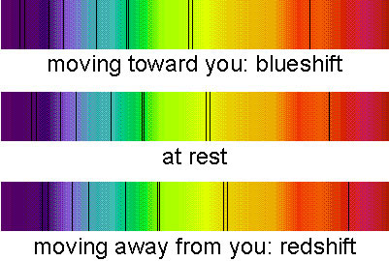

- If the source is moving away from the Earth, the wavelengths and frequencies of the waves will be changed because of the relative motion.
  - An observer will see a longer wavelength and the colour is shifted towards the red – hence the name red shift.
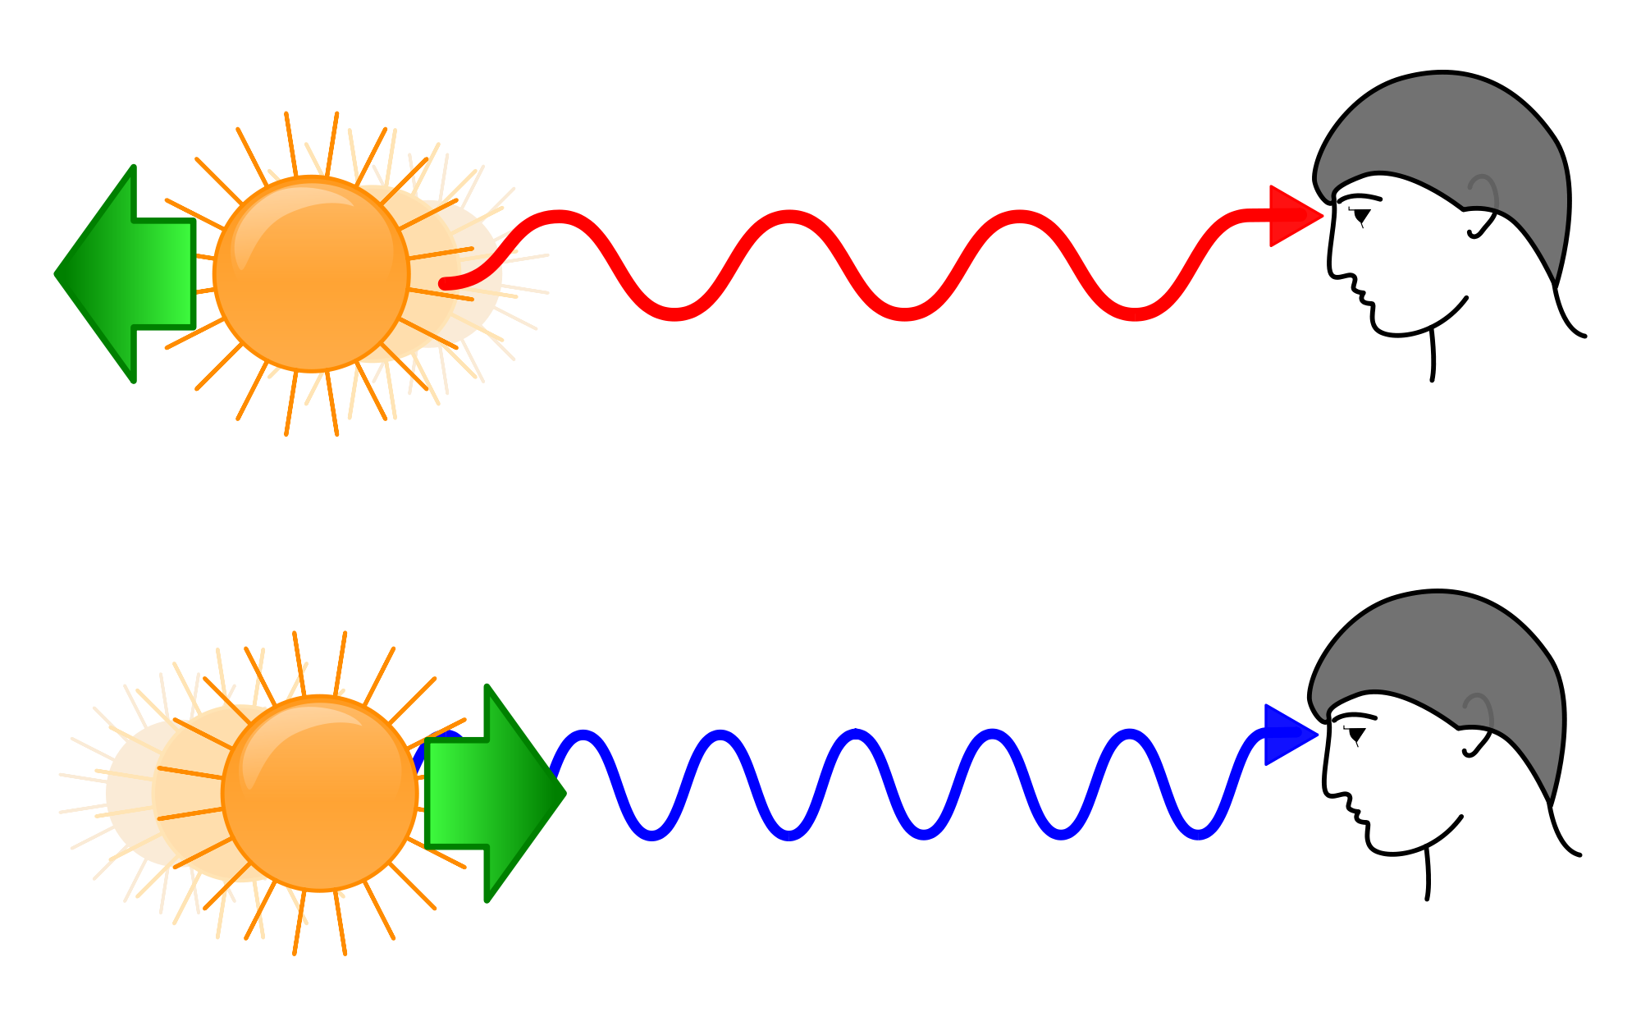

  - The spectrum of the star or galaxy will have the same lines but shifted they will be all shifted towards the red end of the spectrum.

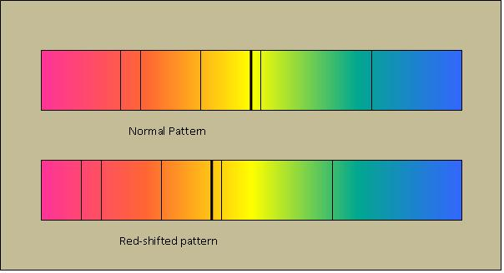

- If the source is moving towards us, then the colour of the emitted radiation shifts towards the blue.

- The shift in the spectra of very distance galaxies is towards longer wavelengths, that is, towards the red end of the spectrum.
  - this means they are moving away from us.
  - this is generally interpreted as evidence that the universe is expanding.

- A moving light source, if it is fast enough, will appear “bluer” as it approaches an observer, and “redder” as it leaves an observer.



- The amount of red shift or blue shift can be used to determine the velocity at which they are moving away or towards Earth.

Red Shift Calculations

- The recessional velocity of a galaxy can also be found from the degree of red shift.

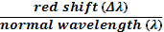
velocity_{galaxy} = x velocity of light (c)

- A particular spectral line from a galaxy far far away is measured to have a red shift from 536.1 nm to 541.2 nm. Find its recessional speed.

Hubble diagram linking redshift velocities to distance
- In the early part of the 20th century it was believed that the universe was in a “steady state” and that the universe was no larger than our galaxy.

- In 1923, Edwin Hubble discovered a way to determine distances to nearby galaxies using the “red shift” principle. Hubble developed equations for determining the size of the universe and proved that the universe was expanding.

- When Hubble plotted the redshift vs. the distance of the galaxies, he found a surprising relation: more distant galaxies are moving faster away from us.

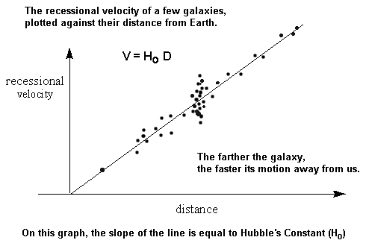

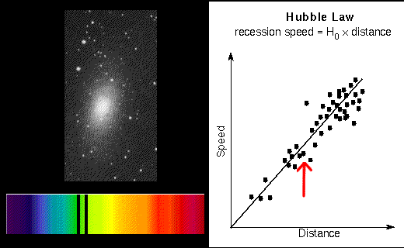
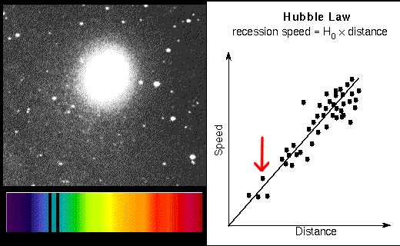

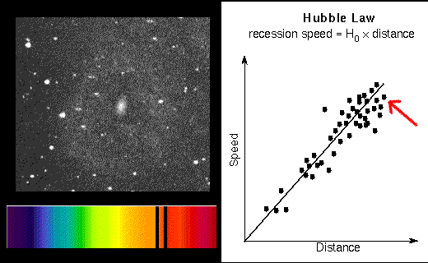
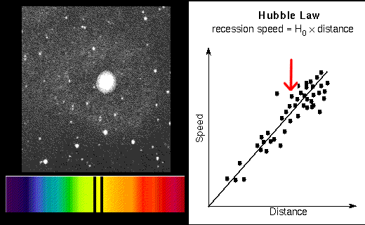

- Hubble concluded that the fainter and smaller the galaxy, the more distant it is, and the faster it is moving away from us, or that the recessional velocity of a galaxy is proportional to its distance from us.

- v = H₀d, with H₀ the constant of proportionality (the Hubble constant) between the distance d to a galaxy and its velocity v.
- The SI unit of H₀ is s⁻¹ but it is most frequently quoted in (km s⁻¹)/Mpc, thus giving the speed in km s⁻¹ of a galaxy one Megaparsec away.

- The reciprocal of H₀ is the age of the universe.

- If H₀ is given as 70 km s⁻¹ Mpc⁻¹, estimate the age of the universe.

- H₀ = 70.0 kms⁻¹ Mpc⁻¹ = 2.27 x 10⁻¹⁸ s⁻¹ = 2.15 x 10⁻² ms⁻¹ ly⁻¹
- 1 ly = 9.46 x 10¹⁵ m = 9.46 x 10¹² km
- 1 pc = 3.26 ly = 3.086 x 10¹⁶ m = 3.26 ly
- 1 Mpc = 3.086 x 10²² m = 3.086 x 10¹⁹ km = 3.26 x 10⁶ ly

- How far away would a galaxy be, if it is moving away at 21 500 kms⁻¹?

- What is the speed of a galaxy if it is 200 million light years away?

- What fraction of the speed of light is this? (0.014)

What does red shift and blue shift mean?

- Most Astronomers and Physicists accept that if the universe is expanding.
- The spectra of distant stars and galaxies show they have been shifted to the red end of the spectrum.
- This can be partially explained by the Doppler effect and suggest the galaxies are moving away from us.
- The further the galaxy is away the more red shifted it is. Therefore, it is moving faster.
- This is the kind of result that would be expected for an expanding universe.

- If the Universe is expanding, then at some time in the past the galaxies must have originated from a single point.
- They developed the idea of the Big Bang theory and proposed that the Universe was the result of a rapid expansion some 13 billion years ago.

Future of the Universe
Closed Universe
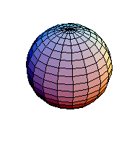
- One model of the universe is the closed universe in which the curvature of space is roughly spherical, this then implies that the universe has finite size.

- An object moving in a straight line in a closed universe would eventually return to its starting point.

- According to most current cosmological theories, the universe is closed if it is sufficiently dense, and therefore possesses enough gravitational force to stop or reverse the expansion started by the big bang (resulting in what is called the big crunch).

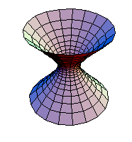
Open Universe
- Another model of the universe is the open model in which the curvature of space is flat or curved away from itself. This then implies that the size of the universe is infinite.

- According to this model, gravity between objects is not able to stop or reverse the expansion of the universe, thus objects continue to move farther and farther apart as space moves outward.

- An object moving in a straight line in an open universe would never return to its starting point.

- According to current cosmological theories, the universe is open if it is insufficiently dense. Such a universe will never end, but will eventually become very cold and dark because stars gradually lose all of their energy.

Cosmological red shift

- The red shift seen in distant galaxies was originally thought to be a Doppler shift, the result of motion away from us.
- This is only part of the explanation.
- Red shift can also be interpreted as the direct consequence of expanding space, as shown in the figure below.

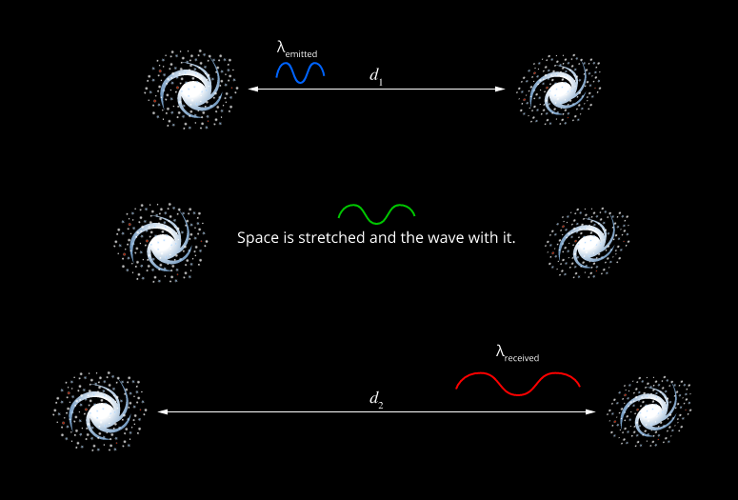

- The wavelength of the radiation increased with space rather than in space.
- This type of red shift is more correctly called a 'cosmological redshift' and was actually predicted by Einstein's general theory of relativity.

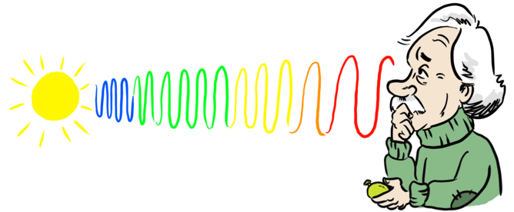
Gravitational red shift

- Einstein predicted that the wavelength of light coming from atoms in a strong gravitational field will lengthen as it escapes the gravitational force.
- The longer wavelength shifts the photon to the red end of the electromagnetic spectrum.

Big Bang Theory

- The Big Bang Theory is the idea of a sudden expansion of an extremely small, hot, and dense body of matter – a singularity.
- According to some cosmological theories it gave rise to everything in the universe between 12 and 20 billion years ago.

Time Line

- 0 to 10⁻⁴³ s
  - all four forces are one fundamental force.
  - Universe is 10⁻³⁵ m wide.
  - Temperature is 10³² K.

- 10⁻⁴³ s to 10⁻³⁶ s
  - gravity separates from other forces.
  - quarks and leptons begin to be formed – as well as their antiparticles.
  - too hot for quarks to coalesce into hadrons.
  - temperature is 10²⁷ K

- 10⁻³⁶ s to 10⁻³² s
  - separation of strong nuclear force.
  - extremely rapid expansion.
  - Universe the size of a large orange.

- 10⁻¹² s
  - end of unified forces
  - protons and neutrons form from quarks.
  - temperature is 10¹⁵ K

- 10⁻⁴ s
  - electrons and positrons form.
  - temperature is 10¹² K

- 10 s
  - protons and neutrons form nuclei.
  - Universe consists of a plasma of nuclei, electrons and photons.
  - temperature is 10⁹ K – too high for electrons to bind to nuclei.

- 1000 s
  - electrons and nuclei form neutral atoms.
  - Helium and deuterium form.
  - temperature is 10⁷ K.

- 380 000 yrs
  - matter and radiation separate
  - temperature is 3000 K.

- 500 million yrs
  - galaxies form.
  - temperature is 10 K.

- 14 billion yrs
  - we are here.
  - temperature is 3 K

Evidence for the Big Bang
- Hubble’s discovery of the expanding space – close galaxies possess small velocities, distant galaxies are receding with the largest velocities. This is consistent with observation from a fragment of an explosion.

- Abundances of light elements – predictions for the creation of light atomic nuclei (eg. Deuterium, ²H; ⁴He; ³He; ⁷Li) during the first few minutes of the Big Bang agree extremely well with those observed now.

- Discovery of the Cosmic Microwave Background (CMB) – using a radio telescope, astronomers found a faint background “glow” which filled the universe. The spectrum and temperature* of the radiation, (2.7° K) that we observe coming from space are consistent with predicted ancient radiation left over from a Big Bang event. The universe is still glowing from the big bang.


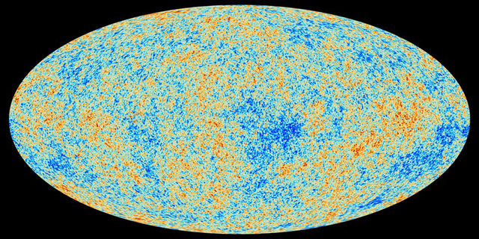

- The WMAP satellite mapped the cosmic microwave background and discovered tiny fluctuations in it.
- This suggests that everything in the Universe is randomly distributed.
- For galaxies to form, there had to be some variation in the structure of the early universe. This would enable local clumps of matter to start to coalesce and form galaxies.
- Once a clump of matter starts to form, its gravity will accelerate the process. As the matter falls inwards, the temperature rises and we have the conditions for the formation of stars.

PP 9.4 p370-7 9.4 Review p 382-3
STAWA p200-1
WSG 5.1 p155-9

High-energy particle accelerators are used to test theories of particle physics, including the Standard Model
This includes deriving and applying the relationship
Force On a Charged Particle Moving in an Electric Field.

- A charged particle can be accelerated using an electric field.
- The size of the force depends on the strength of the electric field, E and the size of the charge on the particle, q.

F = Eq

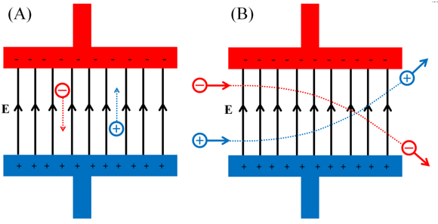

Force On A Charged Particle Moving In A Magnetic Field.

- A free moving charged particle in a magnetic field will experience a force and be deflected.

- It experiences a force as the movement of the charged particles creates its own magnetic field and this magnetic field interacts with the existing magnetic field producing a force which can change the direction of the charged particle.

- The amount of deflection depends upon the magnitude of the force. The direction of the force can be determined by the right hand rule for positive charges.

Mathematical Relationship

F = Bqv sin θ where F = force on charge in newtons (N)
q = charge in coulombs (C)
v = velocity of charge in metres per second (m s⁻¹)
B = magnetic flux density in teslas (T)
sin θ = angle between directions of B and v.

- It should be noted that when the charge is travelling parallel to the field, no electrometric force will be acting on it.

- There must be a component of the velocity cutting the field in order to produce a force.

- While a charged particle remains in the field, the force, and therefore the acceleration, on the charged particle will be perpendicular to the motion.

- This results in the particle undergoing uniform circular motion. The magnetic force acting on a charged particle moving in the magnetic field can be seen to be a centripetal force (F_{c} = ) and therefore Bqv = .
- A beam of positively charged helium ions (He⁺) travelling at 6.00 x 10⁵ m s⁻¹ moves from east to west into a magnetic field of 2.50 x 10⁻² T which is directed vertically upwards. Find the magnitude and direction of the force acting on each ion.

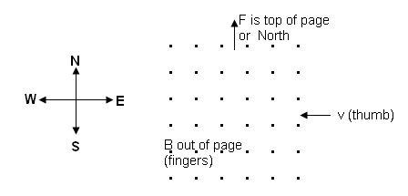

Path of a Charged Particle in a Magnetic Field
- Particles experience a force equal to ‘Bqv’.

- This force can change the direction but not the speed of the particle.

- As the force is always at right angles, the particle is force to follow a circular path.

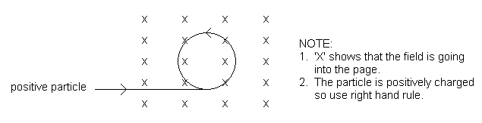
- The force acting on the charge then becomes a centripetal force.

- The force on the particle depends upon the charge, velocity and magnetic field strength.

- To determine the radius of curvature:
You know that F_{(field strength)} = Bqv and F_{(centripetal motion)} =
therefore: where r = radius in metres (m)
m = mass in kilograms (kg)
”v” cancels so v = velocity in metres per second (ms⁻¹)
q = charge in coulombs (C)
B = magnetic flux density in teslas (T)

- From the above relationship, we can see that for a given magnetic field strength, the circular path of a charged particle will depend on its velocity, charge and mass.

- A beam of electrons moves perpendicular to a magnetic field of intensity 6.00 x 10⁻⁵ T. If the electrons have a velocity of 1.20 x 10⁶ ms⁻¹, calculate:
- the force on each electron, (charge electron = 1.60 x 10⁻¹⁹ C)
- the radius of curvature of the path of the electrons. (electron mass = 9.11 x 10⁻³¹ kg)
- the direction the electrons will travel in the field shown.

x x x x x
x x x x x
x x x x x
x x x x x
x x x x x
x x x x x

- A mass spectrometer is being used to determine the mass of a doubly ionized argon atom. The argon ions enter the magnetic field with a velocity of 1.71 x 10⁴ ms⁻¹ and follows a path of 9.40 cm radius. If the magnetic field strength is 5.50 x 10⁻² T,
  - what is the mass of the argon atom?
  - if the field is into the page, and the atom enters the field from the bottom of the page, draw the field and the path the atom will follow.

x x x x x
x x x x x
x x x x x
x x x x x
x x x x x
x x x x x

- Electric and magnetic fields can be used in combination or in sequence to separate and identify moving charged particles.

- If both electric and magnetic fields exist, a moving charged particle will experience a force from each field.

- It should be noted that these fields do not have to be equal or in the same direction.

- While both electric and magnetic fields apply a force to the moving charged particle, the force exerted by a magnetic field depends on the velocity of the particle, F = Bqv. This is not the case in an electric field, E = .

- This different effects of electric and magnetic fields allow charged particles to be separated and identified.

Similarities:
- As can be seen from each equation, both fields are dependent on the magnitude of the field (E and B) and on the magnitude of the charge (q).

Differences:
F = Eq

F = Bqv
- Electric Field: The force is parallel to the field and independent of the velocity of the charged particle.

- Magnetic Field: The force is perpendicular to the field and is proportional to the velocity of the charged particle.

WSG 5.4 p172-6

Some Devices that use electric and/or magnetic fields

The Cathode Ray Oscilloscope (CRO)
- The Cathode Ray Oscilloscope (CRO for short) is like a simple TV set and is used to display and measure electrical information.

- A CRO has a large evacuated tube in which is a heater and electron gun, focusing and accelerating anodes, deflection plates both horizontal and vertical and a fluorescent screen that can display the electrons that hit it.

- It is a simple particle accelerator – electrons are repelled by the negative cathode towards the positive anode.
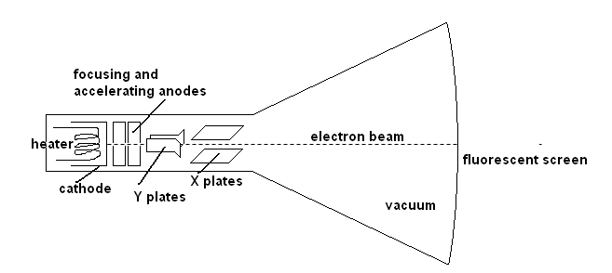

The Velocity Selector – required for mass spectrometer.
- As suggested by the name, this device separates charged particles on the basis of their velocities.

- An electric and magnetic field are set up perpendicular to each other.

- For specific velocities, the charged moving particles will experience equal and opposite forces as they move through the fields and will follow a straight path.

- For the forces to be equal, qvB = Eq and therefore v = . By adjusting the strength of E and B, charged particles with specific velocities can be selected.
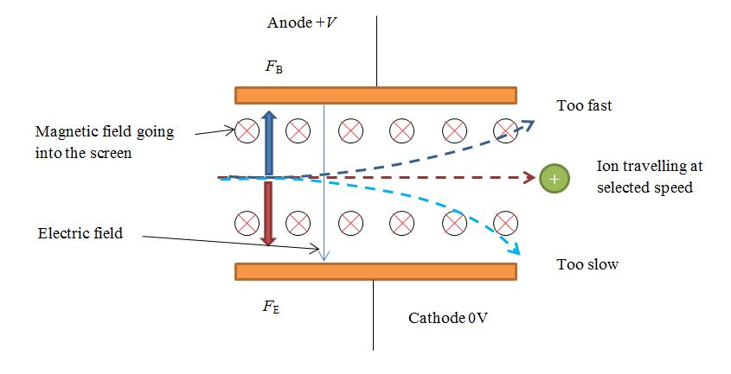
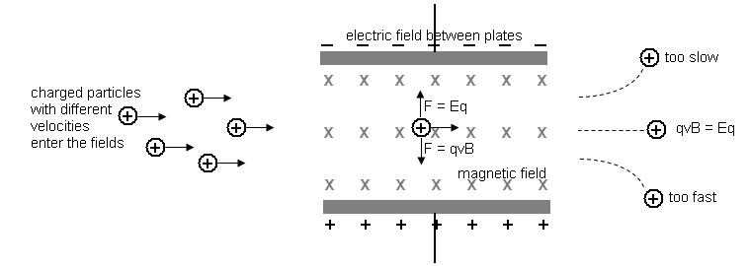

+ + + + + + + + + + + + +
- - - - - - - - - - - - - - - - - - - -
F_{B} = Bqv
F_{e} = Eq

The Mass Spectrometer
- A Mass Spectrometer can be used to measure both the masses and relative concentrations of both atoms and molecules.

- For this reason they can determine the masses of different isotopes of the same element, find and identify traces of contaminants or toxins and be involved in radioactive dating.

- Initially, the substance must be vaporised and then ionised so charged particles are produced.
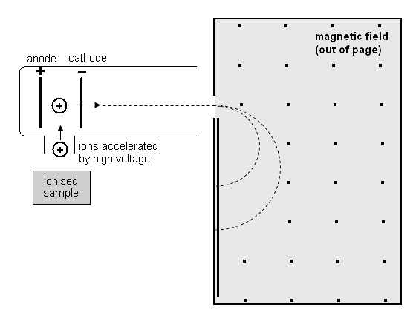
- The ions are accelerated and then pass into the strong magnetic field perpendicular to the direction of the field.

- Now we know that when charged particles enter a magnetic field, the radius of curvature is found by

- From the above relationship, we can see that for a given magnetic field strength, the circular path of a charged particle, and thus its radius, will depend on its velocity, charge and mass.

WSG 5.4 p176-7

Particle Acclerators

Linear Accelerators

- Linear – particles travel down a long, straight track and collide with the target
- Consist of a series of voltage plates and drift tubes.
- Particles are accelerated between each pair of plates.
- Each successive drift tube must be longer to account for the increasing speed (as each plate pair has its voltage turned on and off at the same time).
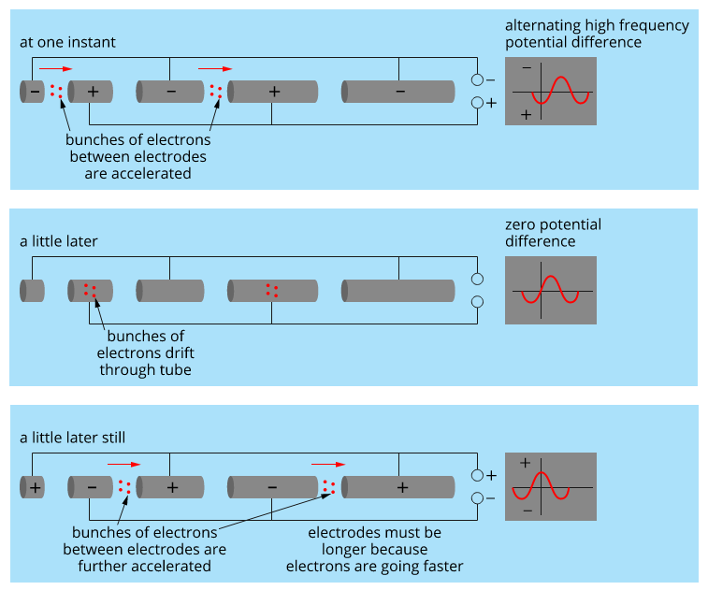

- Particle beams strikes a target at the end of the tunnel – detectors record the events.
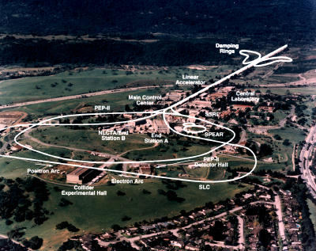
- Subatomic particles and radiation are released.
- LINAC at the Stanford Linear Accelerator Lab in California is about 3 km long

- Uses
- As the first stage of other particle accelerators to inject high speed particles.
- To give light particles (electrons and positrons) the highest possible E_{k}
- For medical applications – to create x-rays and to directly treat tumours.
- Industrial application – non-destructive x-ray testing, sterilization of equipment, food preservation.

Circular Accelerators

- Circular – particles travel around a circle until they collide with the target.
- Do a similar job to linacs.
- Instead of using a long linear track, they propel the particles around a circular track many times. At each pass, the magnetic field is strengthened so that the particle beam accelerates with each consecutive pass.
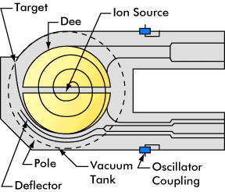
- When the particles are at their highest or desired energy, a target is placed in the path of the beam, in or near the detectors.
- Circular accelerators were the first type of accelerator invented in 1929. In fact, the first cyclotron was only10 cm in diameter.

- This cyclotron has two hollow, D-shaped magnets separated by a small space. The magnetic field causes the ion to move in a circle.
- An oscillating voltage creates an electric field across the gap to accelerate the ions.
- As the particles move faster, the radius of their circular path becomes bigger.

Relativistic effects

- Particles travelling at the close to the speed of light become more massive – therefore, they can never reach the speed of light.
- Since the cyclotron frequency of the RF accelerating voltage depends upon the particle mass, the effects of relativistic mass cause the particle to get progressively more out of step with the accelerating voltage as its speed increases.

- Synchrotrons have the particle beam travelling in a fixed closed-loop path.
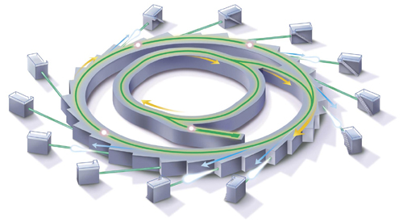
- They can accelerate electrons to almost the speed of light.
- As the electrons are deflected through magnetic fields they release EMR – from IR to x-rays.
- The EMR is channelled down beamlines to experimental workstations.

PP 7.5 p 282-3

- The Large Hadron Collider (LHC) is the world’s largest particle accelerator.
- The tunnel is about 27 km long, 50 to 175 m below ground.
- Involves collisions with hadrons (protons and neutrons) – LHC uses collisions with protons.
- Different protons are directed through the tunnel in opposite directions. When they collide, they create conditions similar to the early universe.
- The LHC has three parts-
  - A particle accelerator
  - Four detectors.
  - A grid – what researchers use to interpret the data.

PP 9.3 p 358-67 9.3 Review p 368-9
WSG 5.3 p167-72

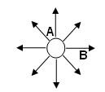
Revision Questions ANSWERS p 26
+
  - Look at the diagram of an electric field around a point charge.
- Is the point charge positive or negative?
- Is the field stronger at A or B?
- Explain your answer.

  - In one region the field lines are parallel and the same distance apart.
- What does this imply about the field?

- Where could you find this field?
  - Consider the following electric field with an electron placed in the middle. Draw an arrow on the electron to show the direction it will be moving.

-
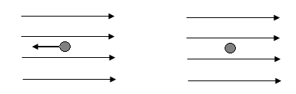

+

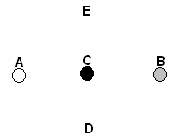
  - Two oppositely charged particles are placed at A and B as shown in the diagram below. A third charged particle (charge unknown) is placed exactly in the middle of the two charges at point C. To increase the force on the particle at C, in which direction should it move?
- towards A
- towards B
- towards A or B
- towards D
- towards E
- towards D or E answer:

  - An electron within a CRO experiences a force of 2.50 x 10⁻¹⁴ N towards the north. Determine the magnitude and direction of the electric field at that point.

  - A mass spectrometer accelerates a proton within an electric field of strength 3.00 x 10⁻⁵ N C⁻¹. Calculate the acceleration of the proton.

  - Two charged parallel plates 8.90 cm apart have an electric field of strength 3.00 x 10⁵ V m⁻¹ set up between them. If a proton was initially at rest, calculate the final velocity of the proton at it moves through the electric field.

  - Below are some magnetic fields. A moving charged particle is shown entering the magnetic field. For each case, state the direction of the force acting on the charged particle.

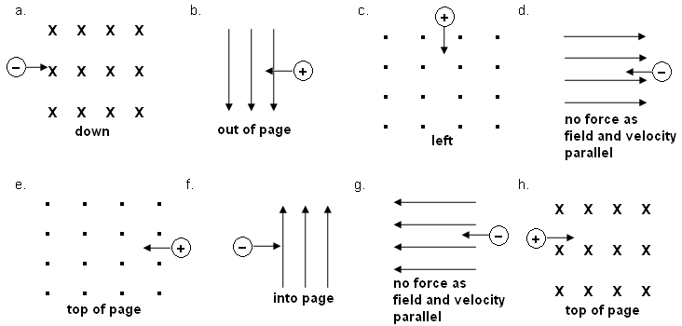

  - A particle with a charge of 4.80 x 10⁻¹⁹ C moves at 5.50 x 10⁵ m s⁻¹ from north to south into a magnetic field directed into the page. If the charge experiences a force of 3.50 x 10⁻¹³ N,
  - Determine the magnitude of the magnetic field.
  - Determine the direction of the movement of the charge within the field.



NOTE: The next question has the particle entering the field at an angle. While it is usual to deal with particles entering magnetic fields perpendicular, it doesn’t specifically say this in the outcome.
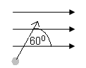
  - A charged particles of mass 2.55 x 10⁻²⁵ kg enters a magnetic field of 0.500 T at 60.0⁰ as shown in the diagram. If the particles has a charge of 6.40 x 10⁻¹⁹ C and is travelling at 125 m s⁻¹, calculate the force on the particle while in the field and the radius of curvature of the path it takes.

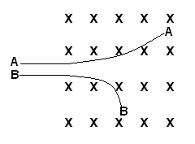
  - The diagram shows two charged particles ‘A’ and ‘B’ as they travel through a magnetic field at the same velocity. Determine the sign on each particle justifying your choice, then give one reason why each has a different radius of curvature.

  - In a CRO, the electric plates are 10.0 mm apart and a potential difference of 5.00 x 10² V is placed across the plates. A magnetic field of 0.250 T is set up so that that a ray of electrons travel undeflected.
- Determine the strength of the electric field between the plates.
- Determine the force on each electron in the ray.
- Determine the speed of the ray of electrons as they pass through the plate.

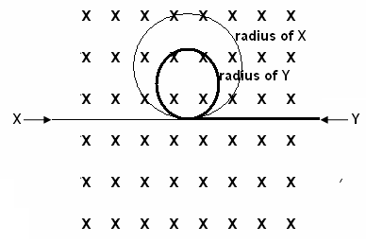


  - Two charged particles X and Y enter a magnetic field as shown on the diagram. X is positively charged while Y is negatively charged. Particle Y has a mass that is three times the mass of particle X. Particle Y is travelling at half the speed of particle X. Draw the path that each will follow showing an approximate relationship between the two radii.


Revision Questions
+
- Look at the diagram of an electric field around a point charge.
- Is the point charge positive or negative? positive
- Is the field stronger at A or B? A
- Explain your answer. The field is stronger at A as A is closer to the point charge. Alternatively, the field lines are closer together at A than at B so the field is stronger.

- In one region the field lines are parallel and the same distance apart.
- What does this imply about the field? the field is the same strength and uniform

- Where could you find this field? between parallel plates.
- Consider the following electric field with an electron placed in the middle. Draw an arrow on the electron to show the direction it will be moving.

-


+


- Two oppositely charged particles are placed at A and B as shown in the diagram below. A third charged particle (charge unknown) is placed exactly in the middle of the two charges at point C. To increase the force on the particle at C, in which direction should it move?
- towards A
- towards B
- towards A or B
- towards D
- towards E
- towards D or E answer: (iii)
Explain your choice. Moving towards either A or B will result in a stronger force as you are moving two charged particles closer together. The force will either be repulsion or attraction. Moving towards either D or E will move the particle further away from A or B so force will decrease.
- An electron within a CRO experiences a force of 2.50 x 10⁻¹⁴ N towards the north. Determine the magnitude and direction of the electric field at that point.

F = 2.50 x 10⁻¹⁴ N
q = 1.60 x 10⁻¹⁹ C

E = 1.56 x 10⁵ N C⁻¹

as it is an electron, it will move in the opposite direction to the field

E = 1.56 x 10⁵ N C⁻¹ South

- A mass spectrometer accelerates a proton within an electric field of strength 3.00 x 10⁻⁵ N C⁻¹. Calculate the acceleration of the proton.

F = Eq
= 3.00 x 10⁻⁵ x 1.6 x 10⁻¹⁹
F = 4.8 x 10⁻²⁴ N

F = ma
a = = 2.874 x 10⁴ ms⁻¹

- Two charged parallel plates 8.90 cm apart have an electric field of strength 3.00 x 10⁵ V m⁻¹ set up between them. If a proton was initially at rest, calculate the final velocity of the proton at it moves through the electric field.

V = Ed
= 3.00 x 10⁵ x 0.089
= 26700 V

W = Vq
= 26700 x 1.60 x 10⁻¹⁹
= 4.272 x 10⁻¹⁵ J

now work = kinetic energy gained so

E_{k} = ½ mv²
  - x 10⁻¹⁵ = ½ x 1.67 x 10⁻²⁷ x v²
v² =
v² = 5.11616 x 10¹²
v = 2.26 x 10⁶ m s⁻¹

- Below are some magnetic fields. A moving charged particle is shown entering the magnetic field. For each case, state the direction of the force acting on the charged particle.



- A particle with a charge of 4.80 x 10⁻¹⁹ C moves at 5.50 x 10⁵ m s⁻¹ from north to south into a magnetic field directed into the page. If the charge experiences a force of 3.50 x 10⁻¹³ N,
  - Determine the magnitude of the magnetic field.
  - Determine the direction of the movement of the charge within the field.

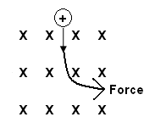
a. F = Bvq
3.50 x 10⁻¹² = B x 5.50 x 10⁵ x 4.80 x 10⁻¹⁹
B = 3.50 x 10⁻¹³ / (5.50 x 10⁵ x 4.80 x 10⁻¹⁹)
B = 1.33 T

b. as shown in the diagram, the force is towards the right or eastwards.

NOTE: The next question has the particle entering the field at an angle. While it is usual to deal with particles entering magnetic fields perpendicular, it doesn’t specifically say this in the outcome.

- A charged particles of mass 2.55 x 10⁻²⁵ kg enters a magnetic field of 0.500 T at 60.0⁰ as shown in the diagram. If the particles has a charge of 6.40 x 10⁻¹⁹ C and is travelling at 125 m s⁻¹, calculate the force on the particle while in the field and the radius of curvature of the path it takes.

F = Bvq sin 60
= 0.500 x 125 x 6.40 x 10⁻¹⁹ x sin 60
F = 3.46 x 10⁻¹⁷ N

r =


- The diagram shows two charged particles ‘A’ and ‘B’ as they travel through a magnetic field at the same velocity. Determine the sign on each particle justifying your choice, then give one reason why each has a different radius of curvature.

Using the right hand rule, the particle that moves towards the top of the page is positive while the one that moves towards the bottom of the page is negative.

r = B and v are constant so
Now B is deflected more (smaller radius) so either its mass is less OR its charge is greater.

- In a CRO, the electric plates are 10.0 mm apart and a potential difference of 5.00 x 10² V is placed across the plates. A magnetic field of 0.250 T is set up so that that a ray of electrons travel undeflected.
- Determine the strength of the electric field between the plates.
- Determine the force on each electron in the ray.
- Determine the speed of the ray of electrons as they pass through the plate.

- E =
E = 50 000
E = 5.00 x 10⁴ V m⁻¹

F = Eq
= 50 000 x 1.6 x 10⁻¹⁹
F = 8.00 x 10⁻¹⁵ N

- F = Bvq
v = 2.00 x 10⁵ m s⁻¹


- Two charged particles X and Y enter a magnetic field as shown on the diagram. X is positively charged while Y is negatively charged. Particle Y has a mass that is three times the mass of particle X. Particle Y is travelling at half the speed of particle X. Draw the path that each will follow showing an approximate relationship between the two radii.

Direction: Using right hand rule, both particles will move
towards the top of the page.

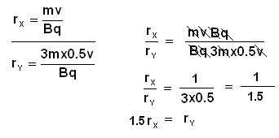
The calculations on the left
show that

r_{y} = 1.5 x r_{x}

r_{Y} = ⅔ r_{X}.

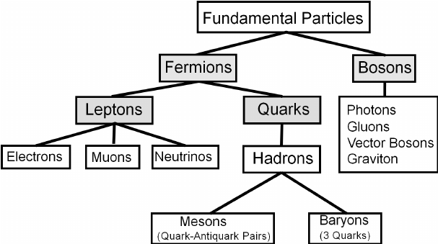
Force carriers
Building blocks of matter
rho
kaon
pion
proton
lambda
neutron
Do not experience strong nuclear force
Experience strong nuclear force
120 types
140 types
The Standard Model is based on the premise that all matter in the universe is made up from elementary matter particles called quarks and leptons; quarks experience the strong nuclear force, leptons do not.

Going deeper into the atom
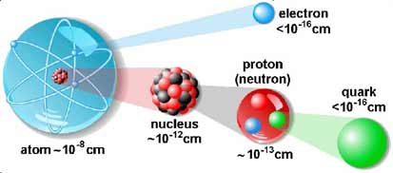


The Standard Model

- Through the use of particle accelerators, scientists now have a deeper understanding of what the atom looks like.

- We now know that the atom is made of much smaller particles than protons, neutrons and electrons.

- The “Standard Model” explains the hundreds of sub atomic particles.

- All matter is made up of fermions (the particles of matter) and bosons (the force carriers that hold matter together)
- Fermions can be quarks, leptons and hadrons (mesons and baryons).
- Bosons can be guage bosons (photons, gluons, W and Z bosons) or Higg’s boson.
Quarks

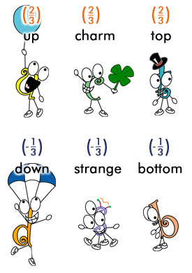
- In 1964, Murray Gell-Mann and George Zweig proposed a quark model, suggesting that protons and neutrons are composed of smaller particles called quarks.

- Some quark facts:

- Quarks are fundamental particles of matter and as such are not made up of any other particles in turn.
- Quarks are never found by themselves and are only found in hadrons.
- There are 6 types of quark (flavours) – up, down, charm, strange, top, bottom
- Up & down quarks are most stable and common and make up protons & neutrons.
- Other quarks are only seen following high energy collisions and decay into up and down quarks.
- Each of the 6 flavours of quark each has an antiparticle (antiquarks), appearing in symbol form with a bar on top) e.g. u and u¯
- Quarks have various intrinsic properties, including electric charge, colour charge, spin, and mass.
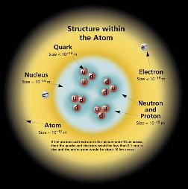
- Colour charge is a characteristic which relates to their binding nature involving the exchange of particles called “gluons”.
- The electric charges for up & down quarks are + 2/3 and – 1/3.
- Every quark has an equivalent antimatter particle or antiquark – making 12 altogether.

- This diagram shows the structure of the “modern atom”.

Leptons

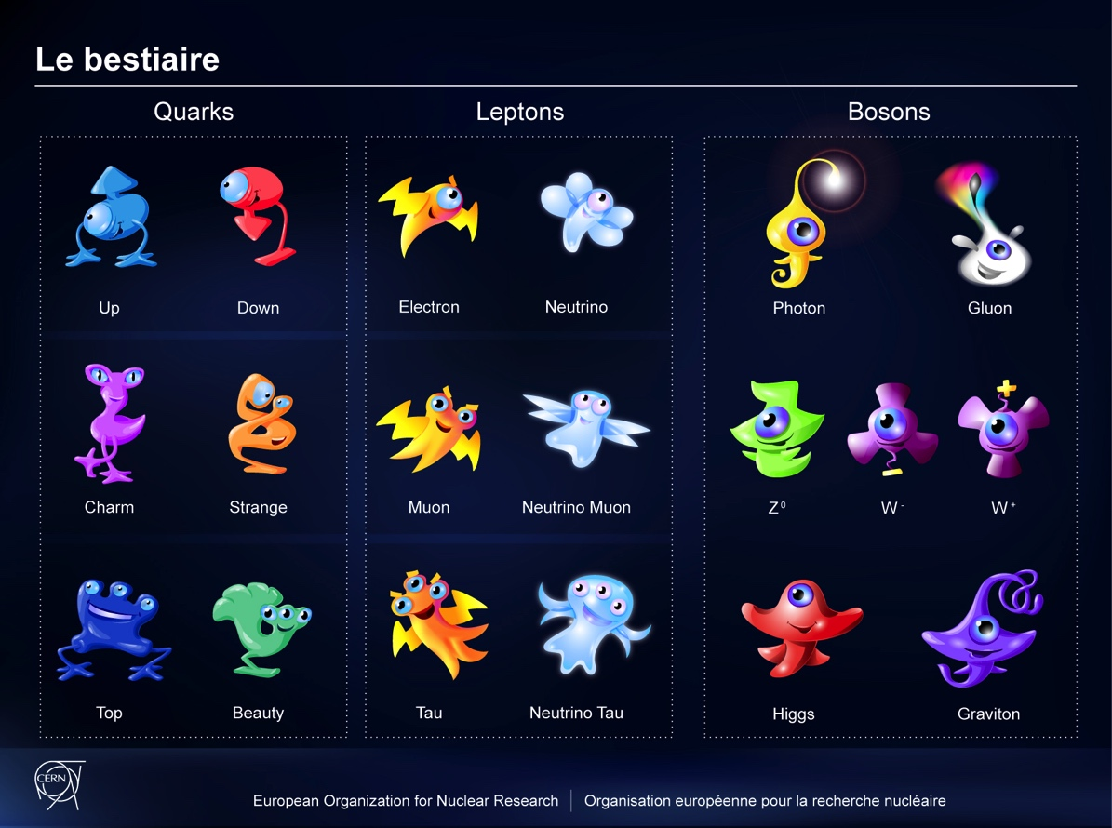
- Leptons and quarks are the basic building blocks of matter – they are seen as the “elementary particle”.

- Some lepton facts:

  - Leptons are similar to quarks.
  - Some leptons are larger than quarks, some are smaller.
  - There are six leptons.
  - The most known lepton is the electron. The electron and the electron neutrino are the stable leptons.
  - Other leptons are taus, muons and three neutrinos.
  - Taus and muons have some electrical charge and are heavier than electrons.

  - Neutrinos have zero charge and very little mass.
  - Neutrinos are very difficult to find.
  - Neutrinos are stable and pass through space without reacting with anything.
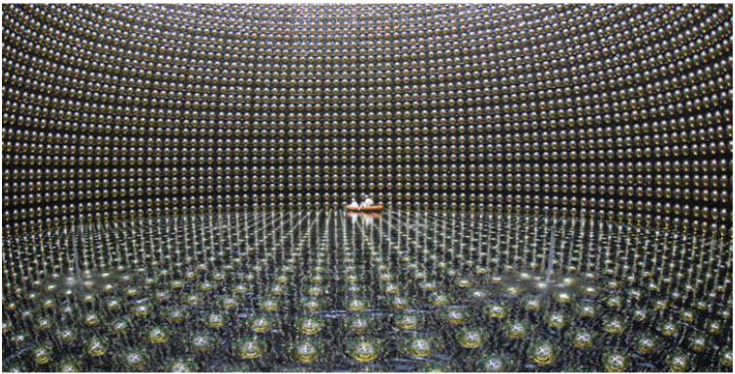

- Unlike quarks, leptons exist on their own.

- For each lepton there in a corresponding antimatter or anti-lepton. The anti-electron is called a “positron” and has a charge of +1. Antiparticles usually have a line above their symbol.

Leptons |  |  | Quarks
Electron | e | -1 | Up | u | + 2/3
Electron-neutrino | ν_{e} | 0 | Down | d | -1/3
Muon | μ | -1 | Charm | c | + 2/3
Muon-neutrino | ν_{μ} | 0 | Strange | s | -1/3
Tau | τ | -1 | Top | t | + 2/3
Tau-neutrino | ν_{τ} | 0 | Bottom | b | -1/3

Hadrons, Baryons and Mesons

- Quarks can be assembled to make up protons and neutrons and other particles which belong to a group called hadrons.

- Hadrons are subdivided into two groups – baryons have 3 quarks and mesons have 2 quarks (actually, 1 quark and 1 antiquark).

- Protons and neutrons are considered to be baryons – they are composed of three quarks each.
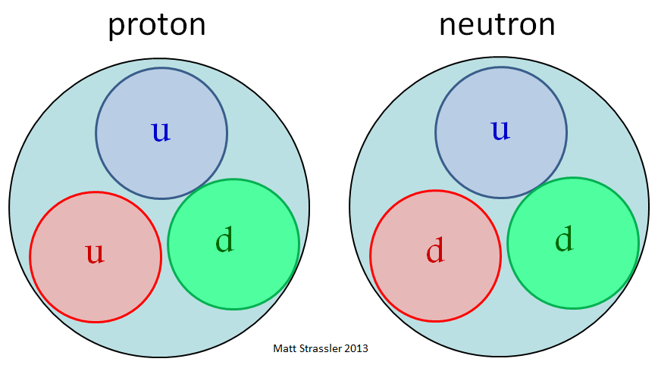
- A proton is composed of two up quarks and a down quark.

- A neutron is composed of an up quark and two down quarks.

- Using the knowledge that an up quark has a charge of + 2/3 and a down quark has a charge of – 1/3, show that the overall charge of a proton is +1 and a neutron is 0.

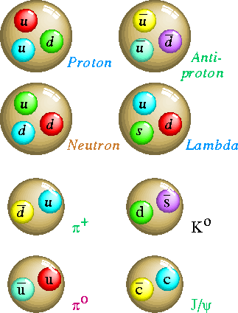
- Examples of baryons and
mesons are shown.
Baryons

Mesons

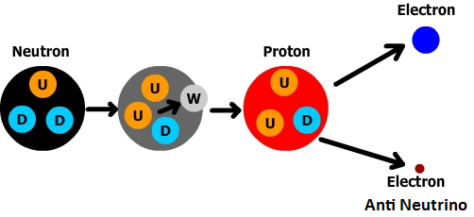

- During nuclear decay, atoms can change into other atoms.
For example, during beta decay carbon-14 transforms into
nitrogen-14.

- The transformation taking place inside the nucleus is:

- Antimatter has been shown to exist. It is very unstable and cannot exist with matter.
- When matter collides with antimatter, they annihilate each other. The matter turns to energy.
- Photons that are produced are unstable and usually decay into other matter/antimatter pairs.

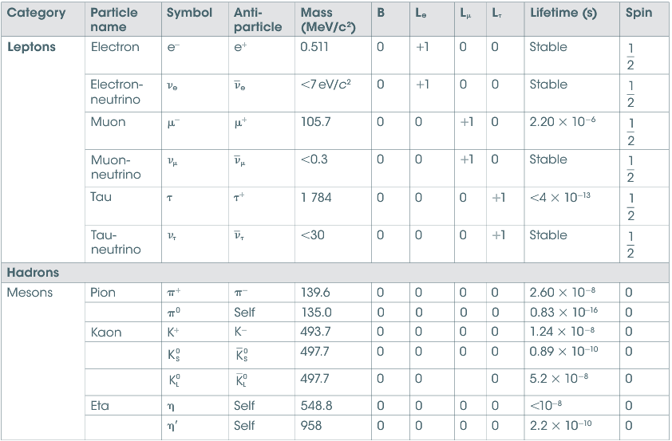
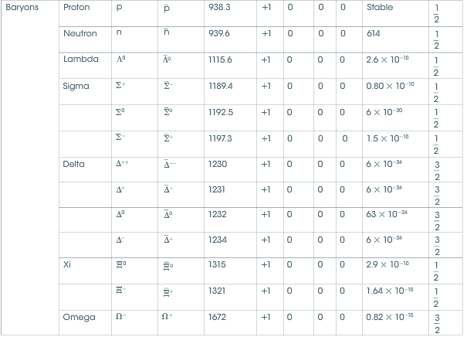
PP 9.1 p 342-7 9.1 Review p 348-9 WSG 5.2 p160-6
Lepton number and baryon number are examples of quantities that are conserved in all reactions between particles; these conservation laws can be used to support or invalidate proposed reactions. Baryons are composite particles made up of quarks.

PARTICLE REACTIONS

Particle Diagrams

- Reaction diagrams show the particles that interact during the reaction (on the LHS) and the particles that result from the reaction (on the RHS).

- The horizontal axis represents time – positive direction pointing to the right.

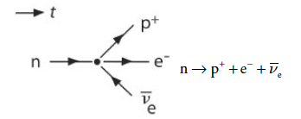
β⁻ decay – turning a neutron into a proton, an electron and an antineutrino

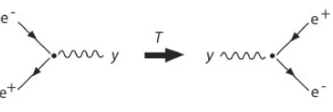
Positron – electron annihilation

and

creation.

- Each particle is represented by a line with an arrow.
- The direction of the arrow matches the direction for time.
- For antiparticles, the direction is reversed (to distinguish particles from antiparticles).

- Straight lines represent particles, squiggly lines represent massless exchange, such as photons.

- The large dot in the centre represents the reaction.

    - Draw a reaction diagram for the process $π^{+}+p → Κ^{+}+ Σ^{+}$
Time

    - Draw a reaction diagram for the process $Ω^{-}→ Λ^{0}+ Κ^{-}$ and $π^{-}→ μ^{-}+ \overline{ν_{μ}}$
Time

Conservation Laws

- For any particle interaction
  - mass and energy must be conserved.
  - charge must be conserved.

    - If a positron and an electron come into contact, they will annihilate. Show that charge and mass/energy are conserved if the collision results in 2 gamma ray photons, each of 0.512 MeV, being produced. Assume the positron and electron are initially at rest.
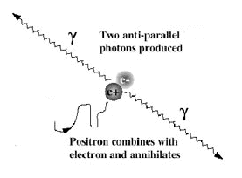

NOTE:
Pair production and annihilation are evidence of the particle nature of light.
Momentum is conserved, gammas move in straight lines (not a spherical wave front)

Quark | Charge (q_{e}) | Baryon number
Up (u) | $$+\frac{2}{3}$$ | $$\frac{1}{3}$$
Down (d) | $$-\frac{1}{3}$$ | $$\frac{1}{3}$$
Top (t) | $$+\frac{2}{3}$$ | $$\frac{1}{3}$$
Bottom (b) | $$-\frac{1}{3}$$ | $$\frac{1}{3}$$
Charm (c) | $$+\frac{2}{3}$$ | $$\frac{1}{3}$$
Strange (s) | $$-\frac{1}{3}$$ | $$\frac{1}{3}$$

- Physicists have discovered two further laws of conservation.
  - conservation of baryon number.
  - conservation of lepton number.

- Every particle has a baryon number.
  - B = +1 for all baryons.
(A quark would have a B of 1/3)
  - B = -1 for all antibaryons.
  - B = 0 for all other particles.

Hadron | Quarks | Mass  (MeV/c²) | Baryon Number | Lepton number
Proton |  | 938.3 | +1 | 0
Neutron |  | 939.6 | +1 | 0
Pion-plus (π⁺) |  | 139.6 | 0 | 0
Sigma-plus |  | 1189.4 | +1 | 0
Charmed Omega |  | 1672.0 | +1 | 0

- Experiments show that for every baryon created in a nuclear reaction, an antibaryon is created.

  - Σ of the baryon number before a reaction = Σ of the baryon number after a reaction

- For the reaction $n→{p+e}^{-}+\overline{ν_{e}}$
  - LHS – neutron has a baryon number of +1
  - RHS – proton has a baryon number of +1
- electron and antineutrino have baryon numbers of 0
  - baryon number is conserved.

    - Use the law of conservation of baryon number to determine whether each of the following reactions can occur.

Time

p̄
Time

- All hadrons are composed of different combinations of fundamental particles called quarks. Baryons are made from a combination of three quarks; antibaryons are made from a combination of three antiquarks; and mesons are made from two quarks; a quark and an antiquark.
All quarks have a baryon number of + 1/3 ; all antiquarks have a baryon number of – 1/3 ; and all baryons have a baryon number of +1.

(a) A pion is a meson. Determine the baryon number of the pion.

Baryon number must be conserved in all reactions.

(b) Determine, by applying conservation of baryon number, whether the following reaction
can take place. Justify your answer with appropriate workings.

proton + neutron → proton + pion

- Show that charge and baryon number are conserved in the following.

$Ω^{-}→ Λ^{0}+ Κ^{-}$ ${p+ e}^{-}→ n+ {\overline{ν}}_{e}$

- There are three types of leptons – electrons (e), muons (μ) and tauons (τ). Each has an associated neutrino (ν).

- Each particle has a lepton number.

Lepton | Charge (q_{e}) | Lepton number | Baryon Number
Electron | -1 | 1 | 0
Electron-neutrino | 0 | 1 | 0
Muon | -1 | 1 | 0
Muon-neutrino | 0 | 1 | 0
Tau | -1 | 1 | 0
Tau-neutrino | 0 | 1 | 0

- Consider the proposed reaction –
A neutron decays to a proton, an electron and an anti-neutrino. $n→{p+e}^{-}+{\overline{ν}}_{e}$
With reference to Lepton number explain whether this reaction is possible or not.
Explain if this reaction is allowed for all conservation laws.

- To extend things further, each particle has an electron lepton number, a muon lepton number and a tau lepton number.
  - electrons and electron neutrinos have electron lepton number (L_{e}) = +1.
  - antielectrons and antielectronneotrinos have L_{e} = -1.
  - all other particles have L_{e} = 0.

  - A similar process occurs with the muon lepton number (L_{μ}) and the tau lepton number (L_{τ}).

Particle | B | L_{e} | L_{μ} | L_{τ}
electron | 0 | +1 | 0 | 0
electron-neutrino | 0 | +1 | 0 | 0
muon | 0 | 0 | +1 | 0
muon-neutrino | 0 | 0 | +1 | 0
Tau | 0 | 0 | 0 | +1
tau-neutrino | 0 | 0 | 0 | +1
- For the reaction $n→{p+e}^{+}+{\overline{ν}}_{e}$
  - LHS – neutron has an electron lepton number of 0
  - RHS – proton has an electron lepton number of 0
- electron has an electron lepton number of +1
- electron antineutrino has an electron lepton number of -1
  - electron lepton number is conserved.

    - Use the law of conservation of lepton number to determine whether each of the following reactions can occur.

Time

e⁻
μ⁻

$$\overline{ν_{e}}$$

$$ν_{μ}$$

$$μ^{+}$$

$$π^{+}$$

$$ν_{e}$$

$$ν_{μ}$$

- Which of the following particle interactions are impossible? Give a reason for your choices.
$n→p+e^{-}+ν_{e}$
$p+n→p+n+p+\overline{p}$
$π^{+}→μ^{-}+\overline{ν_{μ}}$
$∆^{+}→π^{+}+π^{0}$
$p+n→p+μ^{+}+μ^{-}$

- For the following particle interactions, propose particles that could replace the letters X and Y.
  - $X+n→Y+e^{-}$
  - $π^{+}→μ^{+}+X$

PP 9.2 p 350-5 9.2 Review p 356-7
The Standard Model explains three of the four fundamental forces (strong, weak and electromagnetic forces) in terms of an exchange of force-carrying particles called gauge bosons; each force is mediated by a different type of gauge boson

Forces between particles (bosons)

- The nucleus of an atom is very stable.
- The positively charged protons should cause repulsion and cause the nucleus to break apart.
- However, protons and neutrons are held together by the strong nuclear force. This is the strongest force known and works over a very short distance.

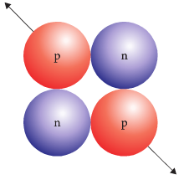
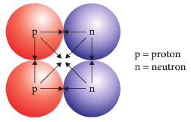

- Quarks are held together by particles called gluons. Gluons carry a special ‘charge-like’ property that creates what is known as the strong force.
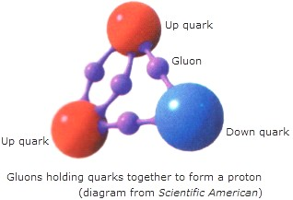
- The force of attraction or repulsion between charged particles and electromagnetic field is caused by particles called photons (“particles of electromagnetic radiation”).

- Forces that charged particles experience are a result of interaction with these photons. This is known as the electromagnetic force.
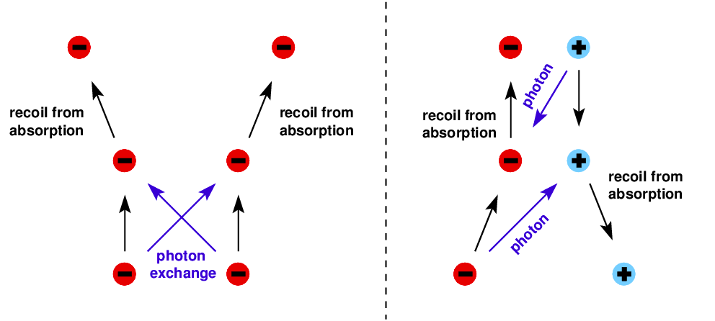
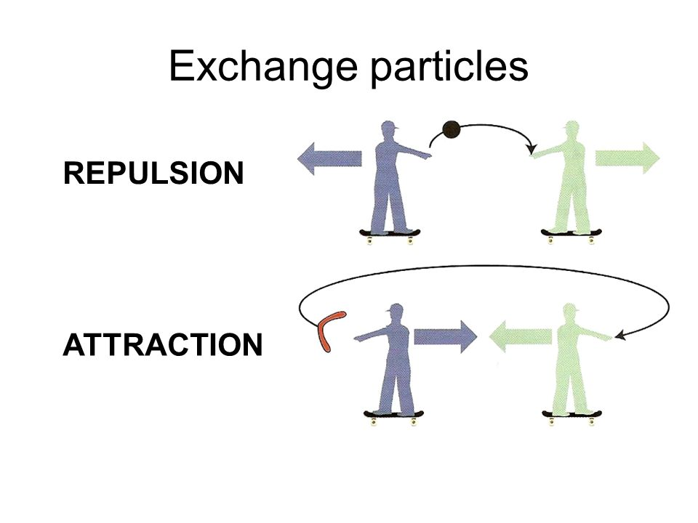

- W and Z bosons are particles that create what is called the weak force. The force is much less than a strong force and acts over a very small distance.

- Weak force is what physicists believe is responsible for the breaking down of some radioactive elements, in the form of beta decay.
- When a neutron transmutates into a proton and releases an electron or beta particle, the weak force has been overcome.
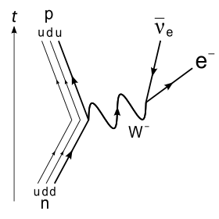
- The graviton is a hypothetical particle that produces the force of gravitational attraction between masses.

Summary of sub atomic particles

- There are six quarks and six leptons which are currently thought to be the building blocks of our universe although many more subatomic particles are being detected and new ways of classifying them are being developed.
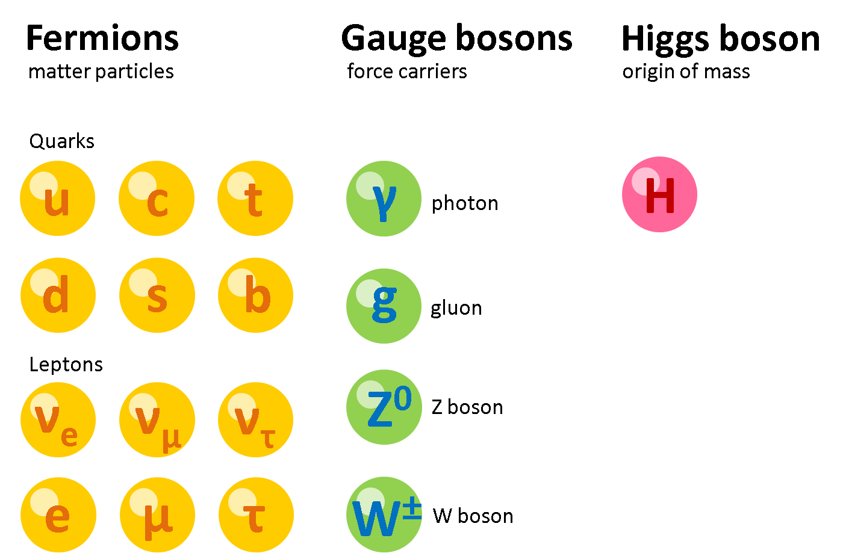

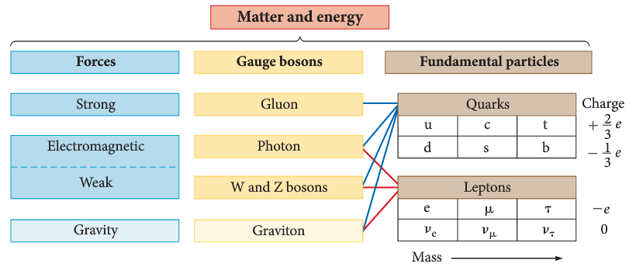

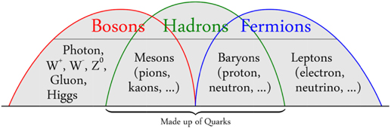
- Hadrons, such as protons and neutrons, interact via strong nuclear forces.
- Leptons, such as electrons and neutrinos interact via weak nuclear forces.

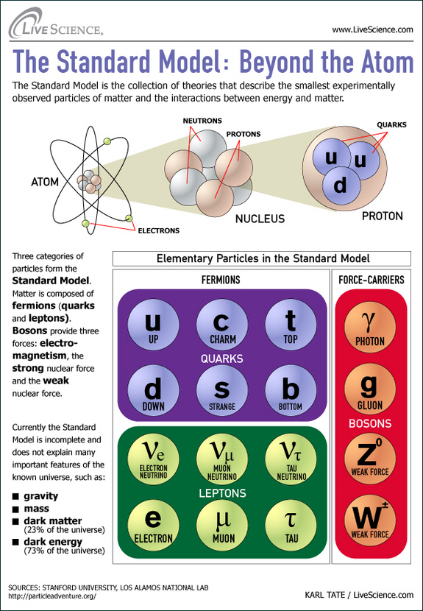

up quark (u)
+ 2/3 charge
lightest quark
forms neutrons
and protons

photon (γ)
mass 0
charge 0
carries electromagnetic force
down quark (d)
- 1/3 charge
forms neutrons
and protons

charm quark (c)
+ 2/3 charge
forms hadrons
gluon (g)
mass 0
charge 0
carries strong force

strange quark (s)
- 1/3 charge
forms hadrons

Z bosons
charge 0
carries weak force
top quark (t)
+ 2/3 charge
heaviest elementary particle

W bosons
charge + or - e
carries weak force

bottom quark (b)
- 1/3 charge

electron neutrino (v_{e}), muon neutrino (v_{μ}), tau neutrino (v_{τ})
charge 0

electron (e), muon (μ), tau (τ)
charge -1

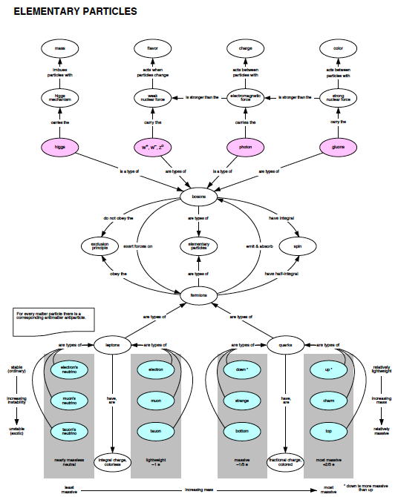

Curriculum Council Resources: PHYSICS answers p 56
Assessment Support Materials for Unit 3B:
Astrophysics section of Particles, waves and quanta

Question 1 (7 marks)
- List two characteristics of all electromagnetic waves. (2 marks)

To answer the following parts of question, refer to the electromagnetic spectrum diagram shown below.
 |  | Wavelength
λ (m) |  |  |  |  |  |  |  |  |  | 10² |  |  |  | 10 |  |  |  |  |  | 1 |  |  |  |  |  |  |  |  |  | 10⁻¹ |  |  |  | 10⁻² |  |  |  | 10⁻³ |  |  |  |  |  | 10⁻⁴ |  |  |  | 10⁻⁵ |  |  |  | 10⁻⁶ |  |  |  | 10⁻⁷ |  |  |  |  |  |  |  | 10⁻⁸ |  |  |  |  | 10⁻⁹ |  |  |  |  | 10⁻¹⁰ |  |  |  |  | 10⁻¹¹ |  |  |  |  |  | 10⁻¹²
Area of  spectrum |  | microwaves  radio frequencies  infrared radiation  ultraviolet  radiation  X-rays  gamma rays
f(Hz) |  |  |  |  |  |  | 10⁶ |  |  |  |  |  | 10⁷ |  |  |  | 10⁸ |  |  |  |  |  |  |  |  |  |  |  | 10⁹ |  |  |  | 10¹⁰ |  |  |  | 10¹¹ |  |  |  |  |  | 10¹² |  |  |  | 10¹³ |  |  |  | 10¹⁴ |  |  |  | 10¹⁵ |  |  |  |  |  |  |  | 10¹⁶ |  |  |  | 10¹⁷ |  |  |  |  |  | 10¹⁸ |  |  |  |  | 10¹⁹ |  |  |  |  |  | 10²⁰
 | Frequency

Note: 1. Shaded areas represent regions of overlap.
2. Gamma rays and X-rays occupy a common region.

- What is the approximate frequency of a short-wave radio wave from the ‘middle’ of the short-wave spectrum? (1 mark)

- Name two types of electromagnetic waves besides visible light that have allowed astronomers to learn more about celestial bodies and the universe. (2 marks)

- Describe the information that each type of wave mentioned in part (c) provides to astronomers.

Question 2 (5 marks)
The Hubble telescope was launched in 1990 and has orbited the Earth since at an average distance of about 570 km above the Earth’s surface.

On the Hubble website, the claim is made that “Hubble is one of NASA’s’ most successful and long-lasting science missions. It has beamed hundred of thousands of images back to Earth, shedding light on many of the great mysteries of astronomy. Its gaze has helped determine the age of the universe, the identity of quasars and the existence of dark energy. “

- Provide three reasons why the Hubble telescope has been so successful compared to larger Earth-based telescopes. (3 marks)

- It has been stated that the Hubble telescope allows us to look back in time to billions of years ago. Explain this statement. (2 marks)

Question 3 (4 marks)
The ‘Big Bang’ theory is a model used to explain the origin of the universe. Describe two pieces of scientific evidence which support this theory.

Question 4 (6 marks)
The Big Bang theory predicts that the universe is expanding.

Describe two possible models that have been proposed to explain the behaviour of the expanding universe.

Question 5 (9 marks)
The Doppler shift in the wavelength of light emitted by galaxies can be used to measure the speed with which they are moving towards or away from the Earth.

Like the Sun, galaxies emit a wide range of wavelengths. The analysis of the absorption spectra of light from galaxies can have two spectral lines missing due to the absorption by calcium ions as light passes through the gases surrounding galaxies.

In the constellation Eridanus which is visible in the western sky between January to April there is a spiral galaxy NGC 1357. The wavelength of one of the calcium absorption lines in the spectrum from NGC 1357 is 399.72 nm. The same line in the calcium spectrum measured in a laboratory on Earth is 396.85 nm.

- Is the spiral galaxy NGC 1357 moving towards or away from the Earth? (1 mark)

- Justify your answer to (a) using a brief explanation and a diagram. (4 marks)

- Calculate the velocity of NGC 1357 using the relationship
Δλ = λ_{shifted} - λ_{rest}
where and λ _{rest} is the wavelength of the fixed source, v is the speed of the moving source and c is the speed of light. (2 marks)

- A star has a recessional velocity of 58.9 km s⁻¹. Calculate the ‘red shift’ that would be expected in the calcium 396.849 nm absorption line from this star.
Use the relationship where Δλ is the change in wavelength, λ _{rest} is the wavelength of the fixed source, v is the speed of the moving source and c is the speed of light. (2 marks)

Question 6 (6 marks)
The Spitzer Space Telescope was launched on August 25, 2003. After more than five-and-a-half years, NASA's Spitzer Space Telescope has run out of the coolant that kept its infrared instruments chilled to -270°C. Since then Spitzer is still making observations but it has warmed to
-240°C.
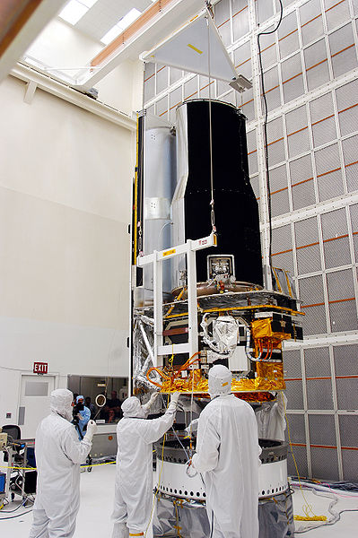

- Why was it necessary to cool the instruments on the Spitzer Space telescope? (1 mark)

- Why is a satellite useful for making infrared observations? (1 mark)

- What property of infrared radiation makes it useful for making astronomical observations?
(2 marks)

- What effect would the change in temperature of the satellite have on the wavelengths that the telescope would be able to observe? (1 mark)

Question 7 (2 marks)
The Herschel Space Observatory was launched in May 2009 by the European Space Agency. It is equipped with a 3.5 meter diameter telescope which will perform photometry and spectroscopy in approximately the 55–672 micrometer range.

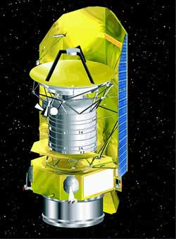

 |  | Wavelength
λ (m) |  |  |  |  |  |  |  |  |  | 10² |  |  |  | 10 |  |  |  |  |  | 1 |  |  |  |  |  |  |  |  |  | 10⁻¹ |  |  |  | 10⁻² |  |  |  | 10⁻³ |  |  |  |  |  | 10⁻⁴ |  |  |  | 10⁻⁵ |  |  |  | 10⁻⁶ |  |  |  | 10⁻⁷ |  |  |  |  |  |  |  | 10⁻⁸ |  |  |  |  | 10⁻⁹ |  |  |  |  | 10⁻¹⁰ |  |  |  |  | 10⁻¹¹ |  |  |  |  |  | 10⁻¹²
Area of  spectrum |  | microwaves  radio frequencies  infrared radiation  ultraviolet  radiation  X-rays  gamma rays
f(Hz) |  |  |  |  |  |  | 10⁶ |  |  |  |  |  | 10⁷ |  |  |  | 10⁸ |  |  |  |  |  |  |  |  |  |  |  | 10⁹ |  |  |  | 10¹⁰ |  |  |  | 10¹¹ |  |  |  |  |  | 10¹² |  |  |  | 10¹³ |  |  |  | 10¹⁴ |  |  |  | 10¹⁵ |  |  |  |  |  |  |  | 10¹⁶ |  |  |  | 10¹⁷ |  |  |  |  |  | 10¹⁸ |  |  |  |  | 10¹⁹ |  |  |  |  |  | 10²⁰
 | Frequency

Which part of the electromagnetic spectrum is the telescope observing? (2 marks)

Question 8 (4 marks)
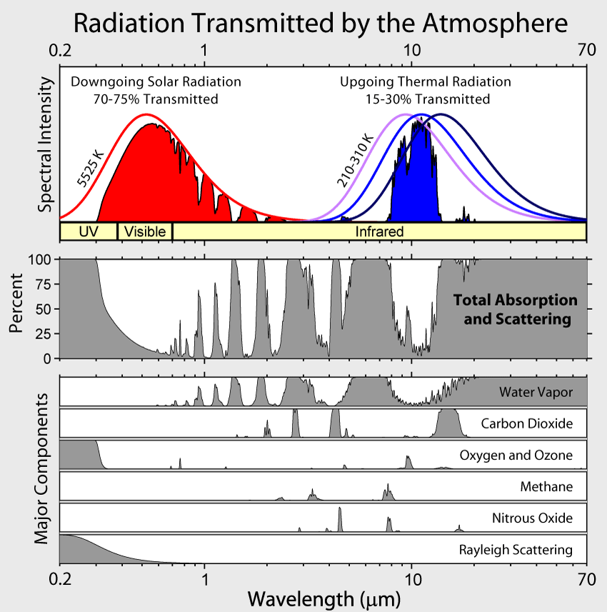

Using the information in the chart above answer the questions.
- Which wavelengths of radiation from space in the visible and the infrared ranges can be observed from Earth? (2 marks)

- Which compounds in the Earth’s atmosphere interfere with stellar observations in the infrared range? (2 marks)

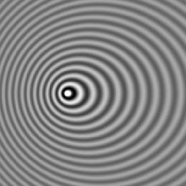
Question 9 (2 marks)
The following photograph is of a vibration pattern produced by a moving object in a ripple tank.

- Which direction is the vibrating source moving towards (left/right/up/down)?
- Explain your answer. (1 mark)

Question 10 (4 marks)
An emergency services vehicle approaches an intersection at 110 km h⁻¹ sounding the horn continuously. The horn has a frequency of 750 Hz. A pedestrian on the footpath at the intersection hears the horn of the approaching at a different frequency.

- Explain what the pedestrian would hear. (1 mark)

(1 mark)

- The observed frequency can be calculated using the formula:
frequency observed = true frequency x

where v is the speed of sound in the medium, v_{s} is the velocity of the moving source.
As the driver approaches the intersection, in the equation is the sign allocated to the velocity of the source + or – to match what the observer hears? Explain your choice. (2 marks)

- Calculate the frequency of the sound heard by the pedestrian. (2 marks)

Question 11 (11 marks)
The visible emission spectrum of a hydrogen atom has three bright lines – red, blue-green, and violet. The blue-green line is caused by the emission of a photon as it moves from energy level 4 to energy level 2. The energy of each level (in eV) can be calculated using the formula

- What is the energy of the photon emitted (in eV) that causes the blue-green line? (1 mark)

- What is the wavelength of this line in nanometres? (3 marks)

- The blue-green line of the hydrogen spectrum from a close galaxy is observed at 537.4 nm. The redshift Z can be calculated
Calculate the red shift of the galaxy. (1 mark)

- For close galaxies receding at a relatively low velocity, the recessional velocity of the galaxy can be calculated from where c is the speed of light.
Use the value of the redshift from (c) to calculate the recessional velocity of the galaxy.(in
km s⁻¹). (2 marks)

- Using Hubble’s law calculate the distance in light-years to this relatively close galaxy using the
redshift value from part (c). (1megaparsec = 3261636.26 light-years)
Hubble’s law: v = H₀ D
v is the velocity (in km s¹), D is the distance ( megaparsecs Mpc ), H₀ is Hubble’s constant
[ H₀ = 74.2 ± 3.6 (km s⁻¹ Mpc⁻¹) ]. (4 marks)

Question 12 (3 marks)
Radio telescopes make observations in the 21 cm radio wavelength band. These radio waves are generated by a neutral hydrogen atom. An electron in energy level 1 normally is spinning in the same direction as the proton. If the electron changes to spin in an opposite direction to the proton, a small amount of energy is released resulting in the 21.106 cm radio emission.

What amount of energy is released (in eV) as an electron changes the direction in which it spins on its axis?

Question 13 (2 marks)
In 1817 Joseph Fraunhofer examined the spectrum from the Sun. He observed a series of dark lines in the otherwise continuous white light spectrum.

- How are the dark lines produced? (1 mark)

- What information about the sun can be gained from these dark lines? (1 mark)

Question 14 (3 marks)
Georges Lemaître (professor of Physics at University of Leuven in 1927) proposed a theory of the nature of the Universe (now known as the ‘Big Bang’ theory), as a logical extension of Einstein’s General Theory of Relativity. ‘Big Bang’ was not Lemaître’s name – this was coined by astronomers who scoffed at the idea. Astronomers now accept Lemaître’s theory as correct. What evidence has been discovered to support this theory?

Question 15 (3 marks)
In 1990 NASA launched the Hubble Space telescope despite knowing of a major defect in its 2.4 m reflecting mirror. The telescope was launched on the very last Saturn 5 rocket capable of carrying the telescope into orbit. In 1993 a Space Shuttle mission replaced the mirror allowing Hubble to function correctly. On Earth the largest (Keck) telescopes have a 10 m diameter mirror and are 4100 m above sea level on a dormant volcano.

- Why are telescopes built so far above sea level? (1 mark)

- Why did NASA put the Hubble telescope into space when bigger telescopes exist on Earth?
(2 marks)

Question 16 (2 marks)

This graph represents the energy intensity released versus wavelength for a “black body”. How can this graph be used to estimate the surface temperature of a star?

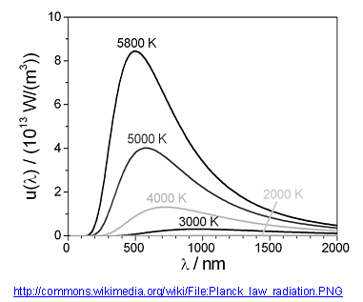

Question 17 (4 marks)

The surface brightness of nebulae can be used to estimate the distance of the nebula from the Earth. The recessional velocity of the nebula can be estimated by the red shift of frequencies emitted in the nebula spectrum. The following data for several nebula was collected from telescopes on Earth in 1997.

Recessional  velocity (km s⁻¹) | Distance (D)  (megaparsecs)
540 | 4.0
650 | 9.6
910 | 10.8
800 | 12.0
915 | 14.3
1050 | 15.5
1200 | 16.1
1300 | 16.2
1350 | 15.8
1400 | 17.4

- On a suitable scale, graph the data (with velocity on the y-axis), the graph paper is on the next page. Draw a line of best fit and determine the gradient of the line. The gradient is an estimate of Hubble’s constant. (3 marks)

- The most recent determination of H₀ obtained in 2009 by using the Hubble Space Telescope yielded a value of H₀ = 74.2 ± 3.6 (km s⁻¹ Mpc⁻¹).
Why is the value based on the data from the Hubble Space Telescope likely to be more accurate?
(1 mark)


velocity
km s⁻¹

1500

1000

500

10
20

distance Mpc

Question 18 (4 marks)

Observing the absorption and emission spectrum from stars can provide us with information on the star such as

surface temperature

chemical composition

rotational velocity

translational velocity.

Explain in a few lines on each of the above how the stellar spectrum gives this information.

http://commons.wikimedia.org/wiki/File:M1_-_The_Crab_Nebula.jpg

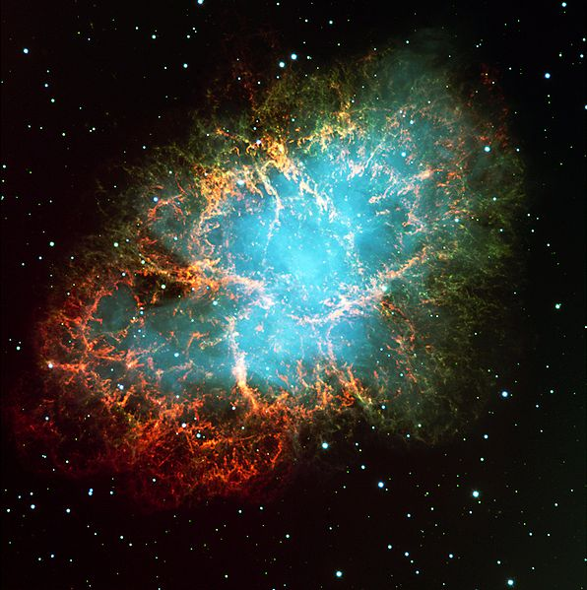
Question 19 (4 marks)
In 1054 AD Chinese astronomers noticed the appearance of a bright star visible in the constellation of Taurus. It was a supernova explosion – the death of a star. The Crab Nebula is the shattered remnant of that massive star. The nebula is about 6 500 light-years away from the Earth and is 5 light-years across, and has a pulsar (a rotating neutron star) at its centre.

- In which year (BC) did this supernova actually take place?(Show your working)

(1 mark)

- What is the distance, in km, across this nebula? (2 marks)

Question 1 (7 marks)
- List two characteristics of all electromagnetic waves. (2 marks)
- travel through a vacuum
- absolute maximum velocity of 3x 10⁸ m s⁻¹ (2 marks)

- What is the approximate frequency of a short-wave radio wave from the ‘middle’ of the short-wave spectrum? 10⁸ Hz (1 mark)

- Name two types of electromagnetic waves besides visible light that have allowed astronomers to learn more about celestial bodies and the universe. (2 marks)

Infrared and radio waves (2 marks)

- Describe the information that each type of wave mentioned in part (c) provides to astronomers.
Infrared astronomy allows astronomers to view low temperature objects that are not able to be observed in the visible region of the EM spectrum.
Radio astronomy allows astronomers to view objects that are obscured by interstellar dust.
(2 marks)

Question 2 (5 marks)

- Provide three reasons why the Hubble telescope has been so successful compared to larger Earth-based telescopes. (3 marks)

- Able to view infra red wavelengths absorbed by water vapour and carbon dioxide in the earths atmosphere
- Able to make observations of the near-ultraviolet absorbed by the earths atmosphere
- Operates continuously
- Light is not obscured by dust or clouds.
- Light is not subject to atmospheric distortion due to differences in refractive indices.
(3 marks)
- It has been stated that the Hubble telescope allows us to look back in time to billions of years ago. Explain this statement. (2 marks)

The Hubble telescope is able to record images of the universe's most distant objects.
The light that forms these images has taken billions of years to reach the telescope. (2 marks)

Question 3 (4 marks)
The ‘Big Bang’ theory is a model used to explain the origin of the universe. Describe two pieces of scientific evidence which support this theory.

- Redshift
- Abundance of light elements
- Hubble’s law
- Cosmic microwave background radiation

Question 4 (6 marks)
The Big Bang theory predicts that the universe is expanding.

Describe two possible models that have been proposed to explain the behaviour of the expanding universe.

- open—expand for ever
- closed universe—stop expanding and then implode on itself

Question 5 (9 marks)

- Is the spiral galaxy NGC 1357 moving towards or away from the Earth? (1 mark)
The spiral galaxy NGC 1357 is moving away from us.
- Justify your answer to (a) using a brief explanation and a diagram. (4 marks)
The wavelength of the calcium line in the spectrum from NGC 1357 has increased.
This is a characteristic of a source moving away from an observer
(Earth 396.85 nm, NGC 1357 399.72 nm) (2 marks +2 for diagram)

- Calculate the velocity of NGC 1357
(2 marks)

v = 2.169 x 10⁶ m s⁻¹
(2 marks)

- A star has a recessional velocity of 58.9 km s⁻¹. Calculate the ‘red shift’ that would be expected in the calcium 396.849 nm absorption line from this star. (2 marks)

Use the relationship

= 58.9 x 1000 x 396.85 x 10⁻⁹
3x 10⁸

= 7.791 x 10⁻¹¹ m = 0.0791 nm
(2 marks)

Question 6 (6 marks)

- Why was it necessary to cool the instruments on the Spitzer Space telescope? (1 mark)
Spitzer telescope views in infrared and must be colder than its surroundings. (1 mark)
- Why is a satellite useful for making infrared observations? (1 mark)
Much of the infrared spectrum from space is absorbed by the Earth’s atmosphere. (1 mark)
- What property of infrared radiation makes it useful for making astronomical observations?
(2 marks)
As a result of the Big Bang, the Universe is expanding. For very fast moving, distant objects the visible spectrum can be Doppler shifted into the infrared. (1 mark)

- What effect would the change in temperature of the satellite have on the wavelengths that the telescope would be able to observe? (1 mark)
The telescope is now observing longer wavelength infrared radiation (1 mark)

Question 7 (2 marks)
Which part of the electromagnetic spectrum is the telescope observing? (2 marks)

55 micrometer = 55 x 10⁻⁶m or 5.5 x 10⁻⁵m
672 micrometer = 6.72 x 10⁻⁴m (1 mark)
From chart of electromagnetic spectrum – this is in infrared range. (1 mark)

Question 8 (4 marks)
- Which wavelengths of radiation from space in the visible and the infrared ranges can be observed from Earth? (2 marks)

Note – wavelength scale is not linear
Visible: 0.4 x 10⁻⁶ m to 0.8 x 10⁻⁶ m (1 mark)

IR: 1.8 x 10⁻⁶ m to 11 x 10⁻⁶ m (1 mark)
- Which compounds in the Earth’s atmosphere interfere with stellar observations in the infrared range? (2 marks)
Water, carbon dioxide (1 mark each)

Question 9 (2 marks)

- Which direction is the vibrating source moving towards (left/right/up/down)? left of picture
- Explain your answer. (1 mark)
Waves are closer together on left resulting in higher frequency as predicted by the Doppler effect. (1 mark)

Question 10 (4 marks)

- Explain what the pedestrian would hear. (1 mark)
Since the source of sound is moving toward the observer it would be at higher frequency.
(1 mark)
- The observed frequency can be calculated
(2 marks)

Must be negative for the denominator to be smaller, to result in a higher value for the frequency. (2 marks)

- Calculate the frequency of the sound heard by the pedestrian. (2 marks)

110 km h⁻¹ = 30.56 m s⁻¹
(1 mark)
Observed frequency = 750 x = 823 Hz
(1 mark)

Question 11 (11 marks)

- What is the energy of the photon emitted (in eV) that causes the blue-green line? (1 mark)

= -0.85 eV = -3.4 eV
E_{4→2} = 3.4 – 0.85 = 2.55 eV
(1 mark)
- What is the wavelength of this line in nanometres? (3 marks)

2.55 ev = 2.55 x 1.6 x 10 ⁻¹⁹ = 4.08 x 10⁻¹⁹ J (1 mark)
E = hc 4.08 x 10⁻¹⁹ = 6.63 x 10⁻³⁴ x 3 x 10⁸
λ λ (1 mark)
λ = 4.875 x 10⁻⁷ m (1 mark)
= 488 nm (1 mark)
- The blue-green line of the hydrogen spectrum from a close galaxy is observed at 537.4 nm.
(1 mark)

= = 0.102 (1 mark)
- For close galaxies receding at a relatively low velocity,
(2 marks)
Z = 0.102 = (1 mark)
v = 3.07 x 10⁷ m s⁻¹
= 3.07 x 10⁴ km s⁻¹
- Using Hubble’s law calculate the distance in light-years
(4 marks)

v = H₀ D
3.07 x 10⁴ = 74.2 + 3.6 x D
D = 3.07 x 10⁴
74.2 + 4.85% (1 mark)
= 413.8 Mpc + 4.85% (1 mark)
= 4.138 x 10⁸ pc + 4.85%
= 1.35 x 10⁹ ly + 4.85% (1 mark)
= 1.35 x 10⁹ + 6.55 x 10⁷ ly (1 mark)

Question 12 (3 marks)
What amount of energy is released (in eV) as an electron changes the direction in which it spins on its axis?

E = hf = hc = 6.63 x 10⁻³⁴ x 3 x 10⁸
λ 0.21106
(1 mark)
= 9.42 x 10⁻²⁵J
(1 mark)
In eV = 9.42 x 10⁻²⁵J = 5.89 x 10⁻⁶ eV
1.6 x 10⁻¹⁹
(1 mark)

Question 13 (2 marks)
- How are the dark lines produced? (1 mark)
The dark lines are caused by absorption of part of the white light from the Sun’s surface as it passes through gases in the Sun’s atmosphere.

- What information about the sun can be gained from these dark lines? (1 mark)
The pattern of lines identifies the elements in the Sun’s atmosphere.

Question 14 (3 marks)

1.Expanding universe – further galaxies are moving away faster than closer galaxies. This is
consistent with an explosion – the particles that travel furthest move fastest.
(1 mark)

2. Hubble discovered distances to galaxies are proportional to their redshifts.
(1 mark)

3. Cosmic microwave background radiation is almost uniform in all directions.
(1 mark)

Question 15 (3 marks)

- Why are telescopes built so far above sea level? (1 mark)

Telescopes high in the mountains look through less of Earth’s atmosphere.

- Why did NASA put the Hubble telescope into space when bigger telescopes exist on Earth?
(2 marks)

Hubble telescope suffers no effects from air distorting the images.
(1 mark)

Hubble also views in infrared range which is not really possible from Earth due to absorption of IR by water in Earth’s atmosphere.
Question 16 (2 marks)

This graph represents the energy intensity released versus wavelength for a “black body”. How can this graph be used to estimate the surface temperature of a star?



yellow

orange
red

Question 17 (4 marks)
- On a suitable scale, graph the data (3 marks)
v

(1 mark for graph)
D

Slope = y₂ – y₁ ₌ 1700
x₂ – x₁ 22
(1 mark)
= 77.3 km s⁻¹ Mpc⁻¹
(1 mark)

- The most recent determination of H₀ obtained in 2009 by using the Hubble Space Telescope yielded a value of H₀ = 74.2 ± 3.6 (km s⁻¹ Mpc⁻¹).
(1 mark)
Hubble has clearer observations being above Earth’s atmosphere.
Recessional velocity and red shift


velocity
km s⁻¹

1500

+
+

+

+

+

1000
+
+

+

+

+
500

10
20

distance Mpc

Question 18 (4 marks)

Observing the absorption and emission spectrum

Explain in a few lines on each of the above how the stellar spectrum gives this information.

Surface temperature – is determined from the colour of radiation (light)
(1 mark)

Chemical composition – solar absorption spectral lines give elements present.
(1 mark)

Rotational velocity - side rotating toward Earth is blue shifted. Side rotating away from Earth is red shifted. Shift gives period of rotation.
(1 mark)

Translational velocity – can be found from red shift
(1 mark)

Question 19 (4 marks)

- In which year (BC) did this supernova actually take place?(Show your working)

1054 – 6500 = - 5446

Explosion was in 5446 BC
(1 mark)
- What is the distance, in km, across this nebula? (2 marks)

5 ly x 365.25 x 24 x 3600 x 3 x 10⁵
(1 mark)
= 4.733 x 10¹³ km
(1 mark)

